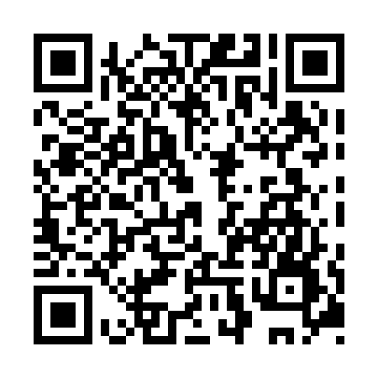
Prayer times for Little Teslin Lake, Yukon, Canada
Wed 1 May 2024 - Fri 31 May 2024
High Latitude Method: Angle Based Rule
Prayer Calculation Method: Islamic Society of North America
Asar Calculation Method: Hanafi

Date | Day | Fajr | Sunrise | Dhuhr | Asr | Maghrib | Isha
1 | Wed | 3:49 | 5:47 | 1:51 | 7:10 | 9:56 | 11:54
2 | Thu | 3:48 | 5:44 | 1:51 | 7:11 | 9:59 | 11:55
3 | Fri | 3:46 | 5:41 | 1:51 | 7:13 | 10:01 | 11:56
4 | Sat | 3:45 | 5:39 | 1:51 | 7:14 | 10:04 | 11:58
5 | Sun | 3:43 | 5:36 | 1:50 | 7:16 | 10:06 | 11:59
6 | Mon | 3:42 | 5:33 | 1:50 | 7:17 | 10:09 | 12:00
7 | Tue | 3:41 | 5:31 | 1:50 | 7:18 | 10:11 | 12:01
8 | Wed | 3:39 | 5:28 | 1:50 | 7:20 | 10:14 | 12:02
9 | Thu | 3:38 | 5:25 | 1:50 | 7:21 | 10:16 | 12:04
10 | Fri | 3:37 | 5:23 | 1:50 | 7:23 | 10:19 | 12:05
11 | Sat | 3:36 | 5:20 | 1:50 | 7:24 | 10:21 | 12:06
12 | Sun | 3:34 | 5:18 | 1:50 | 7:25 | 10:24 | 12:07
13 | Mon | 3:33 | 5:15 | 1:50 | 7:27 | 10:26 | 12:09
14 | Tue | 3:32 | 5:13 | 1:50 | 7:28 | 10:29 | 12:10
15 | Wed | 3:31 | 5:10 | 1:50 | 7:29 | 10:31 | 12:11
16 | Thu | 3:29 | 5:08 | 1:50 | 7:30 | 10:34 | 12:12
17 | Fri | 3:28 | 5:06 | 1:50 | 7:32 | 10:36 | 12:13
18 | Sat | 3:27 | 5:03 | 1:50 | 7:33 | 10:38 | 12:15
19 | Sun | 3:26 | 5:01 | 1:50 | 7:34 | 10:41 | 12:16
20 | Mon | 3:25 | 4:59 | 1:50 | 7:35 | 10:43 | 12:17
21 | Tue | 3:24 | 4:57 | 1:50 | 7:36 | 10:45 | 12:18
22 | Wed | 3:23 | 4:55 | 1:51 | 7:38 | 10:47 | 12:19
23 | Thu | 3:22 | 4:53 | 1:51 | 7:39 | 10:50 | 12:20
24 | Fri | 3:21 | 4:51 | 1:51 | 7:40 | 10:52 | 12:22
25 | Sat | 3:20 | 4:49 | 1:51 | 7:41 | 10:54 | 12:23
26 | Sun | 3:19 | 4:47 | 1:51 | 7:42 | 10:56 | 12:24
27 | Mon | 3:18 | 4:45 | 1:51 | 7:43 | 10:58 | 12:25
28 | Tue | 3:17 | 4:43 | 1:51 | 7:44 | 11:00 | 12:26
29 | Wed | 3:17 | 4:42 | 1:51 | 7:45 | 11:02 | 12:27
30 | Thu | 3:16 | 4:40 | 1:52 | 7:46 | 11:04 | 12:28
31 | Fri | 3:15 | 4:38 | 1:52 | 7:47 | 11:06 | 12:29
Prayer times provided by https://www.salahtimes.com

