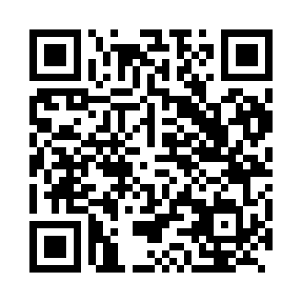
Prayer times for Bedobo, Cameroon
Wed 1 May 2024 - Fri 31 May 2024
High Latitude Method: None
Prayer Calculation Method: Muslim World League
Asar Calculation Method: Shafi

Date | Day | Fajr | Sunrise | Dhuhr | Asr | Maghrib | Isha
1 | Wed | 4:38 | 5:50 | 11:59 | 3:17 | 6:08 | 7:15
2 | Thu | 4:38 | 5:50 | 11:59 | 3:18 | 6:08 | 7:15
3 | Fri | 4:38 | 5:50 | 11:59 | 3:18 | 6:08 | 7:15
4 | Sat | 4:37 | 5:49 | 11:58 | 3:18 | 6:08 | 7:16
5 | Sun | 4:37 | 5:49 | 11:58 | 3:18 | 6:08 | 7:16
6 | Mon | 4:37 | 5:49 | 11:58 | 3:19 | 6:08 | 7:16
7 | Tue | 4:36 | 5:49 | 11:58 | 3:19 | 6:08 | 7:16
8 | Wed | 4:36 | 5:49 | 11:58 | 3:19 | 6:08 | 7:16
9 | Thu | 4:36 | 5:49 | 11:58 | 3:19 | 6:08 | 7:16
10 | Fri | 4:36 | 5:48 | 11:58 | 3:20 | 6:08 | 7:17
11 | Sat | 4:35 | 5:48 | 11:58 | 3:20 | 6:08 | 7:17
12 | Sun | 4:35 | 5:48 | 11:58 | 3:20 | 6:08 | 7:17
13 | Mon | 4:35 | 5:48 | 11:58 | 3:21 | 6:08 | 7:17
14 | Tue | 4:35 | 5:48 | 11:58 | 3:21 | 6:08 | 7:17
15 | Wed | 4:34 | 5:48 | 11:58 | 3:21 | 6:08 | 7:18
16 | Thu | 4:34 | 5:48 | 11:58 | 3:21 | 6:08 | 7:18
17 | Fri | 4:34 | 5:48 | 11:58 | 3:22 | 6:09 | 7:18
18 | Sat | 4:34 | 5:48 | 11:58 | 3:22 | 6:09 | 7:18
19 | Sun | 4:34 | 5:48 | 11:58 | 3:22 | 6:09 | 7:18
20 | Mon | 4:34 | 5:48 | 11:58 | 3:22 | 6:09 | 7:19
21 | Tue | 4:34 | 5:48 | 11:58 | 3:23 | 6:09 | 7:19
22 | Wed | 4:33 | 5:48 | 11:58 | 3:23 | 6:09 | 7:19
23 | Thu | 4:33 | 5:48 | 11:59 | 3:23 | 6:09 | 7:19
24 | Fri | 4:33 | 5:48 | 11:59 | 3:23 | 6:10 | 7:20
25 | Sat | 4:33 | 5:48 | 11:59 | 3:24 | 6:10 | 7:20
26 | Sun | 4:33 | 5:48 | 11:59 | 3:24 | 6:10 | 7:20
27 | Mon | 4:33 | 5:48 | 11:59 | 3:24 | 6:10 | 7:21
28 | Tue | 4:33 | 5:48 | 11:59 | 3:25 | 6:10 | 7:21
29 | Wed | 4:33 | 5:48 | 11:59 | 3:25 | 6:11 | 7:21
30 | Thu | 4:33 | 5:48 | 11:59 | 3:25 | 6:11 | 7:21
31 | Fri | 4:33 | 5:48 | 12:00 | 3:25 | 6:11 | 7:22
Prayer times provided by https://www.salahtimes.com

