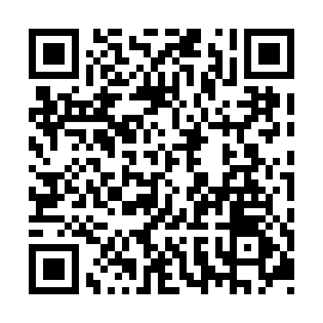
Prayer times for Bayfield Inlet, Ontario, Canada
Wed 1 May 2024 - Fri 31 May 2024
High Latitude Method: Angle Based Rule
Prayer Calculation Method: Islamic Society of North America
Asar Calculation Method: Hanafi

Date | Day | Fajr | Sunrise | Dhuhr | Asr | Maghrib | Isha
1 | Wed | 4:33 | 6:09 | 1:19 | 6:20 | 8:30 | 10:06
2 | Thu | 4:31 | 6:07 | 1:19 | 6:21 | 8:31 | 10:08
3 | Fri | 4:29 | 6:06 | 1:19 | 6:22 | 8:32 | 10:10
4 | Sat | 4:27 | 6:05 | 1:19 | 6:22 | 8:34 | 10:12
5 | Sun | 4:25 | 6:03 | 1:19 | 6:23 | 8:35 | 10:13
6 | Mon | 4:23 | 6:02 | 1:19 | 6:24 | 8:36 | 10:15
7 | Tue | 4:21 | 6:00 | 1:19 | 6:25 | 8:37 | 10:17
8 | Wed | 4:19 | 5:59 | 1:18 | 6:25 | 8:39 | 10:19
9 | Thu | 4:17 | 5:58 | 1:18 | 6:26 | 8:40 | 10:21
10 | Fri | 4:15 | 5:56 | 1:18 | 6:27 | 8:41 | 10:23
11 | Sat | 4:13 | 5:55 | 1:18 | 6:28 | 8:42 | 10:24
12 | Sun | 4:11 | 5:54 | 1:18 | 6:28 | 8:43 | 10:26
13 | Mon | 4:10 | 5:53 | 1:18 | 6:29 | 8:45 | 10:28
14 | Tue | 4:08 | 5:51 | 1:18 | 6:30 | 8:46 | 10:30
15 | Wed | 4:06 | 5:50 | 1:18 | 6:30 | 8:47 | 10:32
16 | Thu | 4:04 | 5:49 | 1:18 | 6:31 | 8:48 | 10:33
17 | Fri | 4:03 | 5:48 | 1:18 | 6:32 | 8:49 | 10:35
18 | Sat | 4:01 | 5:47 | 1:18 | 6:32 | 8:50 | 10:37
19 | Sun | 3:59 | 5:46 | 1:19 | 6:33 | 8:52 | 10:39
20 | Mon | 3:58 | 5:45 | 1:19 | 6:34 | 8:53 | 10:40
21 | Tue | 3:56 | 5:44 | 1:19 | 6:34 | 8:54 | 10:42
22 | Wed | 3:55 | 5:43 | 1:19 | 6:35 | 8:55 | 10:44
23 | Thu | 3:53 | 5:42 | 1:19 | 6:36 | 8:56 | 10:46
24 | Fri | 3:52 | 5:41 | 1:19 | 6:36 | 8:57 | 10:47
25 | Sat | 3:50 | 5:41 | 1:19 | 6:37 | 8:58 | 10:49
26 | Sun | 3:49 | 5:40 | 1:19 | 6:37 | 8:59 | 10:50
27 | Mon | 3:47 | 5:39 | 1:19 | 6:38 | 9:00 | 10:52
28 | Tue | 3:46 | 5:38 | 1:19 | 6:39 | 9:01 | 10:53
29 | Wed | 3:45 | 5:38 | 1:20 | 6:39 | 9:02 | 10:55
30 | Thu | 3:44 | 5:37 | 1:20 | 6:40 | 9:03 | 10:56
31 | Fri | 3:42 | 5:36 | 1:20 | 6:40 | 9:04 | 10:58
Prayer times provided by https://www.salahtimes.com

