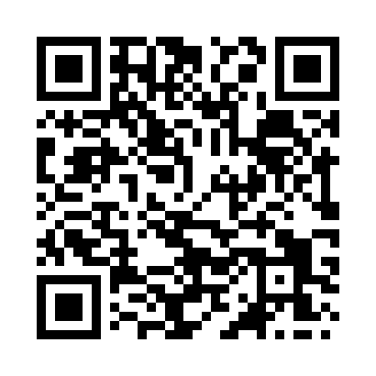
Prayer times for Stromness, Orkney Islands, UK
Mon 1 Jul 2024 - Wed 31 Jul 2024
High Latitude Method: Angle Based Rule
Prayer Calculation Method: Islamic Society of North America
Asar Calculation Method: Hanafi

Date | Day | Fajr | Sunrise | Dhuhr | Asr | Maghrib | Isha
1 | Mon | 2:42 | 4:07 | 1:17 | 7:13 | 10:27 | 11:52
2 | Tue | 2:43 | 4:08 | 1:17 | 7:13 | 10:26 | 11:52
3 | Wed | 2:43 | 4:09 | 1:18 | 7:12 | 10:26 | 11:51
4 | Thu | 2:44 | 4:10 | 1:18 | 7:12 | 10:25 | 11:51
5 | Fri | 2:45 | 4:12 | 1:18 | 7:12 | 10:24 | 11:51
6 | Sat | 2:45 | 4:13 | 1:18 | 7:11 | 10:23 | 11:50
7 | Sun | 2:46 | 4:14 | 1:18 | 7:11 | 10:22 | 11:50
8 | Mon | 2:47 | 4:16 | 1:18 | 7:10 | 10:20 | 11:49
9 | Tue | 2:48 | 4:17 | 1:19 | 7:10 | 10:19 | 11:49
10 | Wed | 2:49 | 4:19 | 1:19 | 7:09 | 10:18 | 11:48
11 | Thu | 2:49 | 4:20 | 1:19 | 7:09 | 10:17 | 11:48
12 | Fri | 2:50 | 4:22 | 1:19 | 7:08 | 10:15 | 11:47
13 | Sat | 2:51 | 4:24 | 1:19 | 7:08 | 10:14 | 11:46
14 | Sun | 2:52 | 4:25 | 1:19 | 7:07 | 10:12 | 11:45
15 | Mon | 2:53 | 4:27 | 1:19 | 7:06 | 10:11 | 11:45
16 | Tue | 2:54 | 4:29 | 1:19 | 7:05 | 10:09 | 11:44
17 | Wed | 2:55 | 4:31 | 1:19 | 7:05 | 10:07 | 11:43
18 | Thu | 2:56 | 4:33 | 1:20 | 7:04 | 10:05 | 11:42
19 | Fri | 2:57 | 4:35 | 1:20 | 7:03 | 10:04 | 11:41
20 | Sat | 2:58 | 4:37 | 1:20 | 7:02 | 10:02 | 11:40
21 | Sun | 2:59 | 4:39 | 1:20 | 7:01 | 10:00 | 11:39
22 | Mon | 3:00 | 4:41 | 1:20 | 7:00 | 9:58 | 11:39
23 | Tue | 3:01 | 4:43 | 1:20 | 6:59 | 9:56 | 11:38
24 | Wed | 3:02 | 4:45 | 1:20 | 6:58 | 9:54 | 11:37
25 | Thu | 3:03 | 4:47 | 1:20 | 6:57 | 9:52 | 11:35
26 | Fri | 3:04 | 4:49 | 1:20 | 6:56 | 9:50 | 11:34
27 | Sat | 3:05 | 4:51 | 1:20 | 6:55 | 9:47 | 11:33
28 | Sun | 3:06 | 4:53 | 1:20 | 6:53 | 9:45 | 11:32
29 | Mon | 3:07 | 4:55 | 1:20 | 6:52 | 9:43 | 11:31
30 | Tue | 3:08 | 4:57 | 1:20 | 6:51 | 9:41 | 11:30
31 | Wed | 3:09 | 5:00 | 1:20 | 6:50 | 9:38 | 11:29
Prayer times provided by https://www.salahtimes.com

