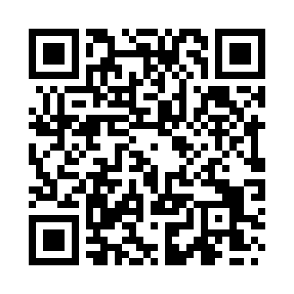
Prayer times for Wemyss Bay, South Lanarkshire, UK
Mon 1 Jul 2024 - Wed 31 Jul 2024
High Latitude Method: Angle Based Rule
Prayer Calculation Method: Islamic Society of North America
Asar Calculation Method: Hanafi

Date | Day | Fajr | Sunrise | Dhuhr | Asr | Maghrib | Isha
1 | Mon | 3:01 | 4:39 | 1:24 | 7:10 | 10:07 | 11:45
2 | Tue | 3:02 | 4:40 | 1:24 | 7:10 | 10:07 | 11:45
3 | Wed | 3:02 | 4:41 | 1:24 | 7:10 | 10:06 | 11:45
4 | Thu | 3:03 | 4:42 | 1:24 | 7:10 | 10:06 | 11:45
5 | Fri | 3:04 | 4:43 | 1:24 | 7:10 | 10:05 | 11:44
6 | Sat | 3:04 | 4:44 | 1:24 | 7:09 | 10:04 | 11:44
7 | Sun | 3:05 | 4:45 | 1:25 | 7:09 | 10:03 | 11:44
8 | Mon | 3:06 | 4:47 | 1:25 | 7:09 | 10:02 | 11:43
9 | Tue | 3:06 | 4:48 | 1:25 | 7:08 | 10:01 | 11:43
10 | Wed | 3:07 | 4:49 | 1:25 | 7:08 | 10:00 | 11:43
11 | Thu | 3:08 | 4:50 | 1:25 | 7:07 | 9:59 | 11:42
12 | Fri | 3:08 | 4:52 | 1:25 | 7:07 | 9:58 | 11:42
13 | Sat | 3:09 | 4:53 | 1:25 | 7:06 | 9:57 | 11:41
14 | Sun | 3:10 | 4:55 | 1:26 | 7:06 | 9:56 | 11:40
15 | Mon | 3:11 | 4:56 | 1:26 | 7:05 | 9:54 | 11:40
16 | Tue | 3:11 | 4:58 | 1:26 | 7:04 | 9:53 | 11:39
17 | Wed | 3:12 | 4:59 | 1:26 | 7:04 | 9:52 | 11:39
18 | Thu | 3:13 | 5:01 | 1:26 | 7:03 | 9:50 | 11:38
19 | Fri | 3:14 | 5:02 | 1:26 | 7:02 | 9:49 | 11:37
20 | Sat | 3:15 | 5:04 | 1:26 | 7:01 | 9:47 | 11:36
21 | Sun | 3:16 | 5:05 | 1:26 | 7:01 | 9:46 | 11:36
22 | Mon | 3:16 | 5:07 | 1:26 | 7:00 | 9:44 | 11:35
23 | Tue | 3:17 | 5:09 | 1:26 | 6:59 | 9:42 | 11:34
24 | Wed | 3:18 | 5:11 | 1:26 | 6:58 | 9:41 | 11:33
25 | Thu | 3:19 | 5:12 | 1:26 | 6:57 | 9:39 | 11:32
26 | Fri | 3:20 | 5:14 | 1:26 | 6:56 | 9:37 | 11:31
27 | Sat | 3:21 | 5:16 | 1:26 | 6:55 | 9:35 | 11:31
28 | Sun | 3:22 | 5:18 | 1:26 | 6:54 | 9:34 | 11:30
29 | Mon | 3:23 | 5:20 | 1:26 | 6:53 | 9:32 | 11:29
30 | Tue | 3:23 | 5:21 | 1:26 | 6:52 | 9:30 | 11:28
31 | Wed | 3:24 | 5:23 | 1:26 | 6:50 | 9:28 | 11:27
Prayer times provided by https://www.salahtimes.com

