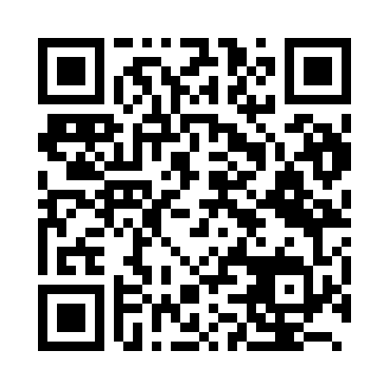
Prayer times for Kushimoto, Japan
Wed 1 May 2024 - Fri 31 May 2024
High Latitude Method: None
Prayer Calculation Method: Muslim World League
Asar Calculation Method: Shafi

Date | Day | Fajr | Sunrise | Dhuhr | Asr | Maghrib | Isha
1 | Wed | 3:37 | 5:09 | 11:54 | 3:36 | 6:40 | 8:06
2 | Thu | 3:36 | 5:08 | 11:54 | 3:36 | 6:41 | 8:07
3 | Fri | 3:35 | 5:07 | 11:54 | 3:36 | 6:41 | 8:08
4 | Sat | 3:33 | 5:06 | 11:54 | 3:36 | 6:42 | 8:09
5 | Sun | 3:32 | 5:05 | 11:54 | 3:36 | 6:43 | 8:10
6 | Mon | 3:31 | 5:04 | 11:54 | 3:36 | 6:44 | 8:11
7 | Tue | 3:30 | 5:03 | 11:53 | 3:36 | 6:44 | 8:12
8 | Wed | 3:28 | 5:02 | 11:53 | 3:36 | 6:45 | 8:13
9 | Thu | 3:27 | 5:01 | 11:53 | 3:36 | 6:46 | 8:14
10 | Fri | 3:26 | 5:00 | 11:53 | 3:36 | 6:47 | 8:15
11 | Sat | 3:25 | 5:00 | 11:53 | 3:36 | 6:47 | 8:16
12 | Sun | 3:24 | 4:59 | 11:53 | 3:36 | 6:48 | 8:17
13 | Mon | 3:23 | 4:58 | 11:53 | 3:37 | 6:49 | 8:18
14 | Tue | 3:22 | 4:57 | 11:53 | 3:37 | 6:50 | 8:19
15 | Wed | 3:21 | 4:57 | 11:53 | 3:37 | 6:50 | 8:20
16 | Thu | 3:20 | 4:56 | 11:53 | 3:37 | 6:51 | 8:21
17 | Fri | 3:19 | 4:55 | 11:53 | 3:37 | 6:52 | 8:22
18 | Sat | 3:18 | 4:55 | 11:53 | 3:37 | 6:53 | 8:23
19 | Sun | 3:17 | 4:54 | 11:53 | 3:37 | 6:53 | 8:24
20 | Mon | 3:16 | 4:53 | 11:53 | 3:37 | 6:54 | 8:25
21 | Tue | 3:15 | 4:53 | 11:54 | 3:37 | 6:55 | 8:26
22 | Wed | 3:14 | 4:52 | 11:54 | 3:37 | 6:55 | 8:27
23 | Thu | 3:13 | 4:52 | 11:54 | 3:37 | 6:56 | 8:28
24 | Fri | 3:12 | 4:51 | 11:54 | 3:38 | 6:57 | 8:29
25 | Sat | 3:12 | 4:51 | 11:54 | 3:38 | 6:57 | 8:30
26 | Sun | 3:11 | 4:50 | 11:54 | 3:38 | 6:58 | 8:31
27 | Mon | 3:10 | 4:50 | 11:54 | 3:38 | 6:59 | 8:32
28 | Tue | 3:10 | 4:49 | 11:54 | 3:38 | 6:59 | 8:33
29 | Wed | 3:09 | 4:49 | 11:54 | 3:38 | 7:00 | 8:34
30 | Thu | 3:08 | 4:49 | 11:55 | 3:38 | 7:01 | 8:35
31 | Fri | 3:08 | 4:48 | 11:55 | 3:39 | 7:01 | 8:35
Prayer times provided by https://www.salahtimes.com

