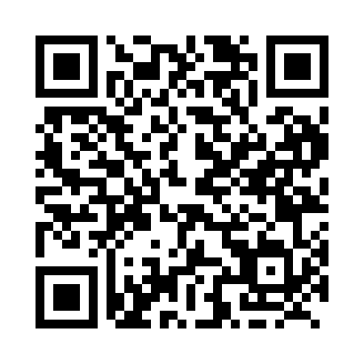
Prayer times for Cherry Point, Alberta, Canada
Mon 1 Apr 2024 - Tue 30 Apr 2024
High Latitude Method: Angle Based Rule
Prayer Calculation Method: Islamic Society of North America
Asar Calculation Method: Hanafi

Date | Day | Fajr | Sunrise | Dhuhr | Asr | Maghrib | Isha
1 | Mon | 5:38 | 7:28 | 2:03 | 6:29 | 8:40 | 10:31
2 | Tue | 5:35 | 7:26 | 2:03 | 6:30 | 8:42 | 10:33
3 | Wed | 5:31 | 7:23 | 2:03 | 6:32 | 8:44 | 10:36
4 | Thu | 5:28 | 7:20 | 2:03 | 6:33 | 8:46 | 10:39
5 | Fri | 5:25 | 7:18 | 2:02 | 6:35 | 8:48 | 10:42
6 | Sat | 5:21 | 7:15 | 2:02 | 6:36 | 8:50 | 10:44
7 | Sun | 5:18 | 7:12 | 2:02 | 6:38 | 8:52 | 10:47
8 | Mon | 5:14 | 7:10 | 2:01 | 6:39 | 8:54 | 10:50
9 | Tue | 5:11 | 7:07 | 2:01 | 6:41 | 8:56 | 10:53
10 | Wed | 5:08 | 7:05 | 2:01 | 6:42 | 8:58 | 10:56
11 | Thu | 5:04 | 7:02 | 2:01 | 6:43 | 9:00 | 10:59
12 | Fri | 5:01 | 7:00 | 2:00 | 6:45 | 9:02 | 11:02
13 | Sat | 4:57 | 6:57 | 2:00 | 6:46 | 9:05 | 11:05
14 | Sun | 4:53 | 6:54 | 2:00 | 6:48 | 9:07 | 11:08
15 | Mon | 4:50 | 6:52 | 2:00 | 6:49 | 9:09 | 11:11
16 | Tue | 4:46 | 6:49 | 1:59 | 6:50 | 9:11 | 11:15
17 | Wed | 4:42 | 6:47 | 1:59 | 6:52 | 9:13 | 11:18
18 | Thu | 4:39 | 6:44 | 1:59 | 6:53 | 9:15 | 11:21
19 | Fri | 4:35 | 6:42 | 1:59 | 6:55 | 9:17 | 11:25
20 | Sat | 4:31 | 6:39 | 1:59 | 6:56 | 9:19 | 11:28
21 | Sun | 4:27 | 6:37 | 1:58 | 6:57 | 9:21 | 11:32
22 | Mon | 4:23 | 6:34 | 1:58 | 6:59 | 9:23 | 11:35
23 | Tue | 4:19 | 6:32 | 1:58 | 7:00 | 9:25 | 11:39
24 | Wed | 4:15 | 6:30 | 1:58 | 7:01 | 9:27 | 11:43
25 | Thu | 4:13 | 6:27 | 1:58 | 7:02 | 9:29 | 11:44
26 | Fri | 4:11 | 6:25 | 1:57 | 7:04 | 9:31 | 11:45
27 | Sat | 4:10 | 6:23 | 1:57 | 7:05 | 9:33 | 11:46
28 | Sun | 4:09 | 6:20 | 1:57 | 7:06 | 9:35 | 11:47
29 | Mon | 4:08 | 6:18 | 1:57 | 7:08 | 9:37 | 11:47
30 | Tue | 4:07 | 6:16 | 1:57 | 7:09 | 9:39 | 11:48
Prayer times provided by https://www.salahtimes.com

