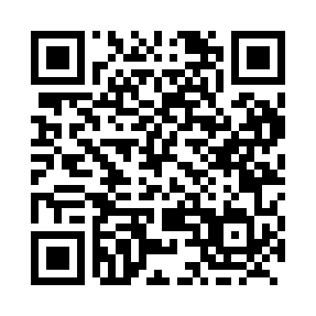
Prayer times for Sheslay, British Columbia, Canada
Mon 1 Jul 2024 - Wed 31 Jul 2024
High Latitude Method: Angle Based Rule
Prayer Calculation Method: Islamic Society of North America
Asar Calculation Method: Hanafi

Date | Day | Fajr | Sunrise | Dhuhr | Asr | Maghrib | Isha
1 | Mon | 3:19 | 4:48 | 1:51 | 7:45 | 10:54 | 12:23
2 | Tue | 3:20 | 4:49 | 1:51 | 7:44 | 10:54 | 12:22
3 | Wed | 3:21 | 4:50 | 1:52 | 7:44 | 10:53 | 12:22
4 | Thu | 3:21 | 4:51 | 1:52 | 7:44 | 10:52 | 12:22
5 | Fri | 3:22 | 4:52 | 1:52 | 7:44 | 10:51 | 12:21
6 | Sat | 3:23 | 4:54 | 1:52 | 7:43 | 10:50 | 12:21
7 | Sun | 3:23 | 4:55 | 1:52 | 7:43 | 10:49 | 12:21
8 | Mon | 3:24 | 4:56 | 1:52 | 7:42 | 10:48 | 12:20
9 | Tue | 3:25 | 4:58 | 1:53 | 7:42 | 10:47 | 12:19
10 | Wed | 3:26 | 4:59 | 1:53 | 7:41 | 10:46 | 12:19
11 | Thu | 3:27 | 5:01 | 1:53 | 7:41 | 10:44 | 12:18
12 | Fri | 3:27 | 5:02 | 1:53 | 7:40 | 10:43 | 12:18
13 | Sat | 3:28 | 5:04 | 1:53 | 7:40 | 10:41 | 12:17
14 | Sun | 3:29 | 5:06 | 1:53 | 7:39 | 10:40 | 12:16
15 | Mon | 3:30 | 5:07 | 1:53 | 7:38 | 10:38 | 12:16
16 | Tue | 3:31 | 5:09 | 1:53 | 7:37 | 10:37 | 12:15
17 | Wed | 3:32 | 5:11 | 1:53 | 7:37 | 10:35 | 12:14
18 | Thu | 3:33 | 5:13 | 1:54 | 7:36 | 10:33 | 12:13
19 | Fri | 3:34 | 5:15 | 1:54 | 7:35 | 10:32 | 12:12
20 | Sat | 3:35 | 5:16 | 1:54 | 7:34 | 10:30 | 12:12
21 | Sun | 3:36 | 5:18 | 1:54 | 7:33 | 10:28 | 12:11
22 | Mon | 3:37 | 5:20 | 1:54 | 7:32 | 10:26 | 12:10
23 | Tue | 3:38 | 5:22 | 1:54 | 7:31 | 10:24 | 12:09
24 | Wed | 3:39 | 5:24 | 1:54 | 7:30 | 10:22 | 12:08
25 | Thu | 3:40 | 5:26 | 1:54 | 7:29 | 10:20 | 12:07
26 | Fri | 3:41 | 5:28 | 1:54 | 7:28 | 10:18 | 12:06
27 | Sat | 3:42 | 5:30 | 1:54 | 7:27 | 10:16 | 12:05
28 | Sun | 3:43 | 5:32 | 1:54 | 7:26 | 10:14 | 12:04
29 | Mon | 3:44 | 5:34 | 1:54 | 7:24 | 10:12 | 12:02
30 | Tue | 3:45 | 5:36 | 1:54 | 7:23 | 10:10 | 12:01
31 | Wed | 3:46 | 5:39 | 1:54 | 7:22 | 10:07 | 12:00
Prayer times provided by https://www.salahtimes.com

