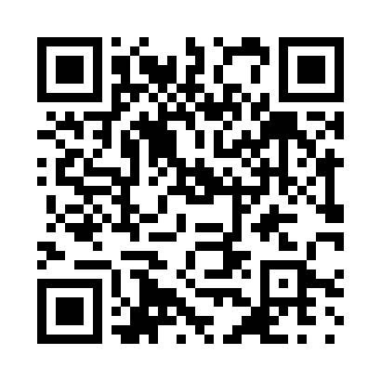
Prayer times for Santa Clara, Cuba
Wed 1 May 2024 - Fri 31 May 2024
High Latitude Method: None
Prayer Calculation Method: Muslim World League
Asar Calculation Method: Shafi

Date | Day | Fajr | Sunrise | Dhuhr | Asr | Maghrib | Isha
1 | Wed | 5:28 | 6:47 | 1:17 | 4:40 | 7:47 | 9:02
2 | Thu | 5:27 | 6:47 | 1:17 | 4:40 | 7:47 | 9:02
3 | Fri | 5:26 | 6:46 | 1:17 | 4:39 | 7:48 | 9:03
4 | Sat | 5:25 | 6:45 | 1:17 | 4:39 | 7:48 | 9:04
5 | Sun | 5:24 | 6:45 | 1:16 | 4:39 | 7:48 | 9:04
6 | Mon | 5:24 | 6:44 | 1:16 | 4:38 | 7:49 | 9:05
7 | Tue | 5:23 | 6:44 | 1:16 | 4:38 | 7:49 | 9:05
8 | Wed | 5:22 | 6:43 | 1:16 | 4:38 | 7:50 | 9:06
9 | Thu | 5:21 | 6:42 | 1:16 | 4:37 | 7:50 | 9:07
10 | Fri | 5:21 | 6:42 | 1:16 | 4:37 | 7:51 | 9:07
11 | Sat | 5:20 | 6:41 | 1:16 | 4:37 | 7:51 | 9:08
12 | Sun | 5:19 | 6:41 | 1:16 | 4:37 | 7:52 | 9:09
13 | Mon | 5:19 | 6:40 | 1:16 | 4:36 | 7:52 | 9:09
14 | Tue | 5:18 | 6:40 | 1:16 | 4:36 | 7:53 | 9:10
15 | Wed | 5:17 | 6:40 | 1:16 | 4:36 | 7:53 | 9:10
16 | Thu | 5:17 | 6:39 | 1:16 | 4:36 | 7:53 | 9:11
17 | Fri | 5:16 | 6:39 | 1:16 | 4:35 | 7:54 | 9:12
18 | Sat | 5:16 | 6:38 | 1:16 | 4:35 | 7:54 | 9:12
19 | Sun | 5:15 | 6:38 | 1:16 | 4:35 | 7:55 | 9:13
20 | Mon | 5:15 | 6:38 | 1:16 | 4:35 | 7:55 | 9:14
21 | Tue | 5:14 | 6:37 | 1:16 | 4:35 | 7:56 | 9:14
22 | Wed | 5:14 | 6:37 | 1:17 | 4:35 | 7:56 | 9:15
23 | Thu | 5:13 | 6:37 | 1:17 | 4:34 | 7:57 | 9:15
24 | Fri | 5:13 | 6:37 | 1:17 | 4:34 | 7:57 | 9:16
25 | Sat | 5:12 | 6:36 | 1:17 | 4:34 | 7:58 | 9:17
26 | Sun | 5:12 | 6:36 | 1:17 | 4:34 | 7:58 | 9:17
27 | Mon | 5:12 | 6:36 | 1:17 | 4:34 | 7:58 | 9:18
28 | Tue | 5:11 | 6:36 | 1:17 | 4:34 | 7:59 | 9:18
29 | Wed | 5:11 | 6:36 | 1:17 | 4:34 | 7:59 | 9:19
30 | Thu | 5:11 | 6:35 | 1:17 | 4:34 | 8:00 | 9:19
31 | Fri | 5:10 | 6:35 | 1:18 | 4:34 | 8:00 | 9:20
Prayer times provided by https://www.salahtimes.com

