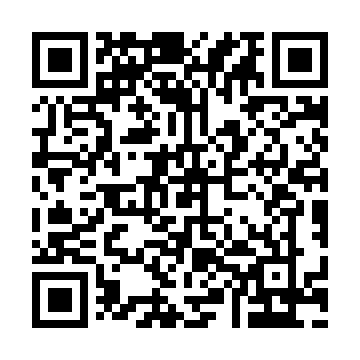
Prayer times for Border Beacon, Quebec, Canada
Mon 1 Apr 2024 - Tue 30 Apr 2024
High Latitude Method: Angle Based Rule
Prayer Calculation Method: Islamic Society of North America
Asar Calculation Method: Hanafi

Date | Day | Fajr | Sunrise | Dhuhr | Asr | Maghrib | Isha
1 | Mon | 3:58 | 5:45 | 12:18 | 4:44 | 6:53 | 8:41
2 | Tue | 3:54 | 5:42 | 12:18 | 4:45 | 6:55 | 8:43
3 | Wed | 3:51 | 5:40 | 12:18 | 4:47 | 6:57 | 8:46
4 | Thu | 3:48 | 5:37 | 12:17 | 4:48 | 6:59 | 8:48
5 | Fri | 3:45 | 5:34 | 12:17 | 4:50 | 7:01 | 8:51
6 | Sat | 3:42 | 5:32 | 12:17 | 4:51 | 7:03 | 8:54
7 | Sun | 3:39 | 5:29 | 12:17 | 4:53 | 7:05 | 8:56
8 | Mon | 3:35 | 5:27 | 12:16 | 4:54 | 7:07 | 8:59
9 | Tue | 3:32 | 5:24 | 12:16 | 4:55 | 7:09 | 9:02
10 | Wed | 3:29 | 5:22 | 12:16 | 4:57 | 7:11 | 9:05
11 | Thu | 3:25 | 5:19 | 12:16 | 4:58 | 7:13 | 9:07
12 | Fri | 3:22 | 5:17 | 12:15 | 4:59 | 7:15 | 9:10
13 | Sat | 3:19 | 5:14 | 12:15 | 5:01 | 7:17 | 9:13
14 | Sun | 3:15 | 5:12 | 12:15 | 5:02 | 7:19 | 9:16
15 | Mon | 3:12 | 5:09 | 12:15 | 5:03 | 7:21 | 9:19
16 | Tue | 3:08 | 5:07 | 12:14 | 5:05 | 7:23 | 9:22
17 | Wed | 3:05 | 5:05 | 12:14 | 5:06 | 7:25 | 9:25
18 | Thu | 3:01 | 5:02 | 12:14 | 5:07 | 7:27 | 9:28
19 | Fri | 2:58 | 5:00 | 12:14 | 5:09 | 7:29 | 9:31
20 | Sat | 2:54 | 4:57 | 12:13 | 5:10 | 7:31 | 9:34
21 | Sun | 2:51 | 4:55 | 12:13 | 5:11 | 7:33 | 9:38
22 | Mon | 2:47 | 4:53 | 12:13 | 5:12 | 7:35 | 9:41
23 | Tue | 2:43 | 4:50 | 12:13 | 5:14 | 7:37 | 9:44
24 | Wed | 2:40 | 4:48 | 12:13 | 5:15 | 7:39 | 9:48
25 | Thu | 2:36 | 4:46 | 12:13 | 5:16 | 7:41 | 9:51
26 | Fri | 2:32 | 4:43 | 12:12 | 5:17 | 7:42 | 9:55
27 | Sat | 2:28 | 4:41 | 12:12 | 5:19 | 7:44 | 9:58
28 | Sun | 2:26 | 4:39 | 12:12 | 5:20 | 7:46 | 10:00
29 | Mon | 2:25 | 4:37 | 12:12 | 5:21 | 7:48 | 10:00
30 | Tue | 2:23 | 4:34 | 12:12 | 5:22 | 7:50 | 10:01
Prayer times provided by https://www.salahtimes.com

