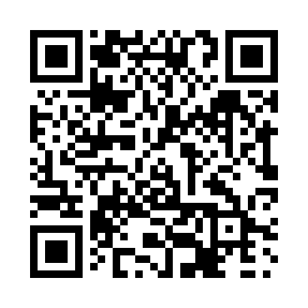
Prayer times for Chu Chua, British Columbia, Canada
Mon 1 Apr 2024 - Tue 30 Apr 2024
High Latitude Method: Angle Based Rule
Prayer Calculation Method: Islamic Society of North America
Asar Calculation Method: Hanafi

Date | Day | Fajr | Sunrise | Dhuhr | Asr | Maghrib | Isha
1 | Mon | 4:58 | 6:34 | 1:04 | 5:32 | 7:35 | 9:11
2 | Tue | 4:56 | 6:32 | 1:04 | 5:33 | 7:37 | 9:13
3 | Wed | 4:53 | 6:30 | 1:04 | 5:34 | 7:38 | 9:16
4 | Thu | 4:51 | 6:28 | 1:03 | 5:36 | 7:40 | 9:18
5 | Fri | 4:48 | 6:26 | 1:03 | 5:37 | 7:42 | 9:20
6 | Sat | 4:45 | 6:23 | 1:03 | 5:38 | 7:43 | 9:22
7 | Sun | 4:42 | 6:21 | 1:03 | 5:39 | 7:45 | 9:24
8 | Mon | 4:40 | 6:19 | 1:02 | 5:40 | 7:47 | 9:26
9 | Tue | 4:37 | 6:17 | 1:02 | 5:41 | 7:48 | 9:28
10 | Wed | 4:34 | 6:14 | 1:02 | 5:43 | 7:50 | 9:31
11 | Thu | 4:32 | 6:12 | 1:02 | 5:44 | 7:52 | 9:33
12 | Fri | 4:29 | 6:10 | 1:01 | 5:45 | 7:53 | 9:35
13 | Sat | 4:26 | 6:08 | 1:01 | 5:46 | 7:55 | 9:37
14 | Sun | 4:23 | 6:06 | 1:01 | 5:47 | 7:57 | 9:40
15 | Mon | 4:21 | 6:04 | 1:01 | 5:48 | 7:58 | 9:42
16 | Tue | 4:18 | 6:02 | 1:00 | 5:49 | 8:00 | 9:44
17 | Wed | 4:15 | 5:59 | 1:00 | 5:50 | 8:02 | 9:46
18 | Thu | 4:12 | 5:57 | 1:00 | 5:52 | 8:03 | 9:49
19 | Fri | 4:09 | 5:55 | 1:00 | 5:53 | 8:05 | 9:51
20 | Sat | 4:07 | 5:53 | 12:59 | 5:54 | 8:07 | 9:54
21 | Sun | 4:04 | 5:51 | 12:59 | 5:55 | 8:08 | 9:56
22 | Mon | 4:01 | 5:49 | 12:59 | 5:56 | 8:10 | 9:58
23 | Tue | 3:58 | 5:47 | 12:59 | 5:57 | 8:12 | 10:01
24 | Wed | 3:55 | 5:45 | 12:59 | 5:58 | 8:13 | 10:03
25 | Thu | 3:53 | 5:43 | 12:59 | 5:59 | 8:15 | 10:06
26 | Fri | 3:50 | 5:41 | 12:58 | 6:00 | 8:17 | 10:08
27 | Sat | 3:47 | 5:39 | 12:58 | 6:01 | 8:18 | 10:11
28 | Sun | 3:44 | 5:37 | 12:58 | 6:02 | 8:20 | 10:14
29 | Mon | 3:41 | 5:35 | 12:58 | 6:03 | 8:21 | 10:16
30 | Tue | 3:38 | 5:33 | 12:58 | 6:04 | 8:23 | 10:19
Prayer times provided by https://www.salahtimes.com

