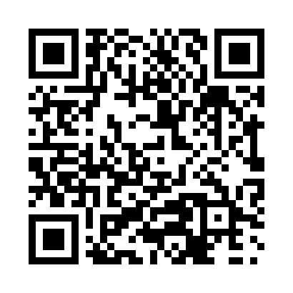
Prayer times for Sunnybrook, Nova Scotia, Canada
Mon 1 Jul 2024 - Wed 31 Jul 2024
High Latitude Method: Angle Based Rule
Prayer Calculation Method: Islamic Society of North America
Asar Calculation Method: Hanafi

Date | Day | Fajr | Sunrise | Dhuhr | Asr | Maghrib | Isha
1 | Mon | 3:45 | 5:37 | 1:21 | 6:42 | 9:05 | 10:58
2 | Tue | 3:45 | 5:38 | 1:22 | 6:42 | 9:05 | 10:57
3 | Wed | 3:46 | 5:38 | 1:22 | 6:42 | 9:05 | 10:57
4 | Thu | 3:47 | 5:39 | 1:22 | 6:42 | 9:05 | 10:56
5 | Fri | 3:48 | 5:40 | 1:22 | 6:42 | 9:04 | 10:55
6 | Sat | 3:49 | 5:40 | 1:22 | 6:42 | 9:04 | 10:55
7 | Sun | 3:51 | 5:41 | 1:22 | 6:42 | 9:03 | 10:54
8 | Mon | 3:52 | 5:42 | 1:23 | 6:41 | 9:03 | 10:53
9 | Tue | 3:53 | 5:43 | 1:23 | 6:41 | 9:03 | 10:52
10 | Wed | 3:54 | 5:43 | 1:23 | 6:41 | 9:02 | 10:51
11 | Thu | 3:55 | 5:44 | 1:23 | 6:41 | 9:01 | 10:50
12 | Fri | 3:57 | 5:45 | 1:23 | 6:41 | 9:01 | 10:49
13 | Sat | 3:58 | 5:46 | 1:23 | 6:40 | 9:00 | 10:48
14 | Sun | 3:59 | 5:47 | 1:23 | 6:40 | 9:00 | 10:47
15 | Mon | 4:01 | 5:48 | 1:23 | 6:40 | 8:59 | 10:45
16 | Tue | 4:02 | 5:49 | 1:24 | 6:39 | 8:58 | 10:44
17 | Wed | 4:04 | 5:49 | 1:24 | 6:39 | 8:57 | 10:43
18 | Thu | 4:05 | 5:50 | 1:24 | 6:38 | 8:56 | 10:41
19 | Fri | 4:07 | 5:51 | 1:24 | 6:38 | 8:56 | 10:40
20 | Sat | 4:08 | 5:52 | 1:24 | 6:38 | 8:55 | 10:39
21 | Sun | 4:10 | 5:53 | 1:24 | 6:37 | 8:54 | 10:37
22 | Mon | 4:11 | 5:54 | 1:24 | 6:37 | 8:53 | 10:36
23 | Tue | 4:13 | 5:55 | 1:24 | 6:36 | 8:52 | 10:34
24 | Wed | 4:14 | 5:56 | 1:24 | 6:35 | 8:51 | 10:33
25 | Thu | 4:16 | 5:57 | 1:24 | 6:35 | 8:50 | 10:31
26 | Fri | 4:17 | 5:58 | 1:24 | 6:34 | 8:49 | 10:29
27 | Sat | 4:19 | 6:00 | 1:24 | 6:34 | 8:48 | 10:28
28 | Sun | 4:21 | 6:01 | 1:24 | 6:33 | 8:47 | 10:26
29 | Mon | 4:22 | 6:02 | 1:24 | 6:32 | 8:45 | 10:24
30 | Tue | 4:24 | 6:03 | 1:24 | 6:32 | 8:44 | 10:23
31 | Wed | 4:26 | 6:04 | 1:24 | 6:31 | 8:43 | 10:21
Prayer times provided by https://www.salahtimes.com

