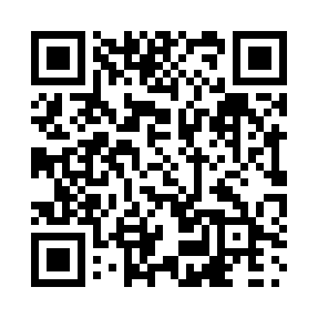
Prayer times for Clanwilliam, Manitoba, Canada
Wed 1 May 2024 - Fri 31 May 2024
High Latitude Method: Angle Based Rule
Prayer Calculation Method: Islamic Society of North America
Asar Calculation Method: Hanafi

Date | Day | Fajr | Sunrise | Dhuhr | Asr | Maghrib | Isha
1 | Wed | 4:22 | 6:13 | 1:36 | 6:43 | 9:00 | 10:52
2 | Thu | 4:19 | 6:12 | 1:36 | 6:44 | 9:02 | 10:55
3 | Fri | 4:16 | 6:10 | 1:36 | 6:44 | 9:03 | 10:57
4 | Sat | 4:14 | 6:08 | 1:36 | 6:45 | 9:05 | 11:00
5 | Sun | 4:11 | 6:06 | 1:36 | 6:46 | 9:06 | 11:02
6 | Mon | 4:08 | 6:05 | 1:36 | 6:47 | 9:08 | 11:05
7 | Tue | 4:06 | 6:03 | 1:36 | 6:48 | 9:09 | 11:07
8 | Wed | 4:03 | 6:01 | 1:36 | 6:49 | 9:11 | 11:10
9 | Thu | 4:00 | 6:00 | 1:36 | 6:50 | 9:12 | 11:13
10 | Fri | 3:58 | 5:58 | 1:36 | 6:51 | 9:14 | 11:15
11 | Sat | 3:55 | 5:57 | 1:36 | 6:52 | 9:15 | 11:18
12 | Sun | 3:52 | 5:55 | 1:36 | 6:53 | 9:17 | 11:20
13 | Mon | 3:50 | 5:54 | 1:36 | 6:53 | 9:18 | 11:23
14 | Tue | 3:47 | 5:52 | 1:36 | 6:54 | 9:20 | 11:26
15 | Wed | 3:45 | 5:51 | 1:36 | 6:55 | 9:21 | 11:28
16 | Thu | 3:43 | 5:50 | 1:36 | 6:56 | 9:22 | 11:29
17 | Fri | 3:42 | 5:48 | 1:36 | 6:57 | 9:24 | 11:30
18 | Sat | 3:42 | 5:47 | 1:36 | 6:58 | 9:25 | 11:31
19 | Sun | 3:41 | 5:46 | 1:36 | 6:58 | 9:27 | 11:31
20 | Mon | 3:40 | 5:44 | 1:36 | 6:59 | 9:28 | 11:32
21 | Tue | 3:40 | 5:43 | 1:36 | 7:00 | 9:29 | 11:33
22 | Wed | 3:39 | 5:42 | 1:36 | 7:01 | 9:31 | 11:33
23 | Thu | 3:39 | 5:41 | 1:36 | 7:02 | 9:32 | 11:34
24 | Fri | 3:38 | 5:40 | 1:36 | 7:02 | 9:33 | 11:35
25 | Sat | 3:38 | 5:39 | 1:36 | 7:03 | 9:34 | 11:35
26 | Sun | 3:37 | 5:38 | 1:36 | 7:04 | 9:35 | 11:36
27 | Mon | 3:37 | 5:37 | 1:37 | 7:04 | 9:37 | 11:37
28 | Tue | 3:36 | 5:36 | 1:37 | 7:05 | 9:38 | 11:37
29 | Wed | 3:36 | 5:35 | 1:37 | 7:06 | 9:39 | 11:38
30 | Thu | 3:36 | 5:34 | 1:37 | 7:06 | 9:40 | 11:39
31 | Fri | 3:35 | 5:34 | 1:37 | 7:07 | 9:41 | 11:39
Prayer times provided by https://www.salahtimes.com

