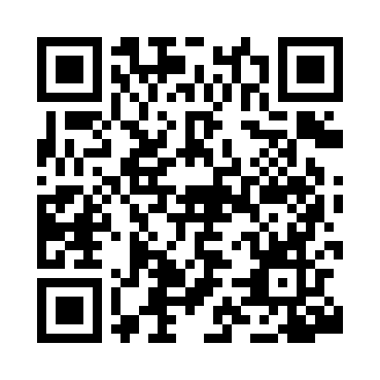
Prayer times for Chascomus, Argentina
Wed 1 May 2024 - Fri 31 May 2024
High Latitude Method: None
Prayer Calculation Method: Muslim World League
Asar Calculation Method: Shafi

Date | Day | Fajr | Sunrise | Dhuhr | Asr | Maghrib | Isha
1 | Wed | 6:03 | 7:30 | 12:49 | 3:46 | 6:08 | 7:29
2 | Thu | 6:04 | 7:31 | 12:49 | 3:45 | 6:07 | 7:29
3 | Fri | 6:05 | 7:31 | 12:49 | 3:44 | 6:06 | 7:28
4 | Sat | 6:05 | 7:32 | 12:49 | 3:43 | 6:05 | 7:27
5 | Sun | 6:06 | 7:33 | 12:49 | 3:42 | 6:04 | 7:26
6 | Mon | 6:07 | 7:34 | 12:49 | 3:42 | 6:03 | 7:25
7 | Tue | 6:07 | 7:35 | 12:49 | 3:41 | 6:02 | 7:24
8 | Wed | 6:08 | 7:35 | 12:48 | 3:40 | 6:01 | 7:24
9 | Thu | 6:09 | 7:36 | 12:48 | 3:39 | 6:00 | 7:23
10 | Fri | 6:09 | 7:37 | 12:48 | 3:39 | 5:59 | 7:22
11 | Sat | 6:10 | 7:38 | 12:48 | 3:38 | 5:58 | 7:21
12 | Sun | 6:11 | 7:39 | 12:48 | 3:37 | 5:58 | 7:21
13 | Mon | 6:11 | 7:39 | 12:48 | 3:37 | 5:57 | 7:20
14 | Tue | 6:12 | 7:40 | 12:48 | 3:36 | 5:56 | 7:19
15 | Wed | 6:13 | 7:41 | 12:48 | 3:35 | 5:55 | 7:19
16 | Thu | 6:13 | 7:42 | 12:48 | 3:35 | 5:55 | 7:18
17 | Fri | 6:14 | 7:43 | 12:48 | 3:34 | 5:54 | 7:18
18 | Sat | 6:15 | 7:43 | 12:48 | 3:34 | 5:53 | 7:17
19 | Sun | 6:15 | 7:44 | 12:49 | 3:33 | 5:53 | 7:17
20 | Mon | 6:16 | 7:45 | 12:49 | 3:33 | 5:52 | 7:16
21 | Tue | 6:16 | 7:46 | 12:49 | 3:32 | 5:51 | 7:16
22 | Wed | 6:17 | 7:46 | 12:49 | 3:32 | 5:51 | 7:15
23 | Thu | 6:18 | 7:47 | 12:49 | 3:31 | 5:50 | 7:15
24 | Fri | 6:18 | 7:48 | 12:49 | 3:31 | 5:50 | 7:14
25 | Sat | 6:19 | 7:48 | 12:49 | 3:30 | 5:49 | 7:14
26 | Sun | 6:19 | 7:49 | 12:49 | 3:30 | 5:49 | 7:14
27 | Mon | 6:20 | 7:50 | 12:49 | 3:30 | 5:48 | 7:13
28 | Tue | 6:20 | 7:50 | 12:49 | 3:29 | 5:48 | 7:13
29 | Wed | 6:21 | 7:51 | 12:50 | 3:29 | 5:48 | 7:13
30 | Thu | 6:21 | 7:52 | 12:50 | 3:29 | 5:47 | 7:13
31 | Fri | 6:22 | 7:52 | 12:50 | 3:29 | 5:47 | 7:12
Prayer times provided by https://www.salahtimes.com

