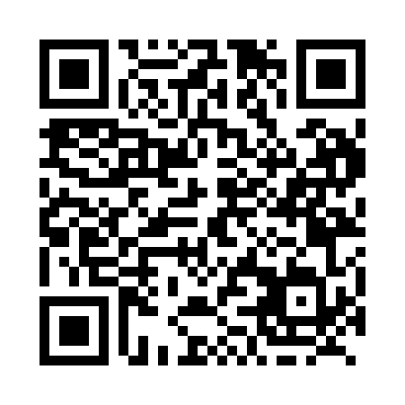
Prayer times for Glenboro, Manitoba, Canada
Wed 1 May 2024 - Fri 31 May 2024
High Latitude Method: Angle Based Rule
Prayer Calculation Method: Islamic Society of North America
Asar Calculation Method: Hanafi

Date | Day | Fajr | Sunrise | Dhuhr | Asr | Maghrib | Isha
1 | Wed | 4:25 | 6:14 | 1:34 | 6:40 | 8:56 | 10:45
2 | Thu | 4:23 | 6:12 | 1:34 | 6:40 | 8:57 | 10:47
3 | Fri | 4:20 | 6:10 | 1:34 | 6:41 | 8:59 | 10:49
4 | Sat | 4:17 | 6:08 | 1:34 | 6:42 | 9:00 | 10:52
5 | Sun | 4:15 | 6:07 | 1:34 | 6:43 | 9:02 | 10:54
6 | Mon | 4:12 | 6:05 | 1:34 | 6:44 | 9:03 | 10:56
7 | Tue | 4:10 | 6:04 | 1:34 | 6:45 | 9:04 | 10:59
8 | Wed | 4:07 | 6:02 | 1:34 | 6:46 | 9:06 | 11:01
9 | Thu | 4:05 | 6:01 | 1:34 | 6:47 | 9:07 | 11:04
10 | Fri | 4:02 | 5:59 | 1:34 | 6:48 | 9:09 | 11:06
11 | Sat | 4:00 | 5:58 | 1:34 | 6:48 | 9:10 | 11:08
12 | Sun | 3:58 | 5:56 | 1:34 | 6:49 | 9:12 | 11:11
13 | Mon | 3:55 | 5:55 | 1:34 | 6:50 | 9:13 | 11:13
14 | Tue | 3:53 | 5:53 | 1:34 | 6:51 | 9:14 | 11:16
15 | Wed | 3:50 | 5:52 | 1:34 | 6:52 | 9:16 | 11:18
16 | Thu | 3:48 | 5:51 | 1:34 | 6:53 | 9:17 | 11:20
17 | Fri | 3:46 | 5:49 | 1:34 | 6:53 | 9:19 | 11:23
18 | Sat | 3:43 | 5:48 | 1:34 | 6:54 | 9:20 | 11:25
19 | Sun | 3:41 | 5:47 | 1:34 | 6:55 | 9:21 | 11:28
20 | Mon | 3:40 | 5:46 | 1:34 | 6:56 | 9:22 | 11:28
21 | Tue | 3:39 | 5:45 | 1:34 | 6:56 | 9:24 | 11:29
22 | Wed | 3:39 | 5:43 | 1:34 | 6:57 | 9:25 | 11:30
23 | Thu | 3:38 | 5:42 | 1:34 | 6:58 | 9:26 | 11:30
24 | Fri | 3:38 | 5:41 | 1:34 | 6:59 | 9:27 | 11:31
25 | Sat | 3:37 | 5:40 | 1:34 | 6:59 | 9:29 | 11:32
26 | Sun | 3:37 | 5:39 | 1:34 | 7:00 | 9:30 | 11:32
27 | Mon | 3:37 | 5:38 | 1:34 | 7:01 | 9:31 | 11:33
28 | Tue | 3:36 | 5:38 | 1:35 | 7:01 | 9:32 | 11:33
29 | Wed | 3:36 | 5:37 | 1:35 | 7:02 | 9:33 | 11:34
30 | Thu | 3:36 | 5:36 | 1:35 | 7:03 | 9:34 | 11:35
31 | Fri | 3:35 | 5:35 | 1:35 | 7:03 | 9:35 | 11:35
Prayer times provided by https://www.salahtimes.com

