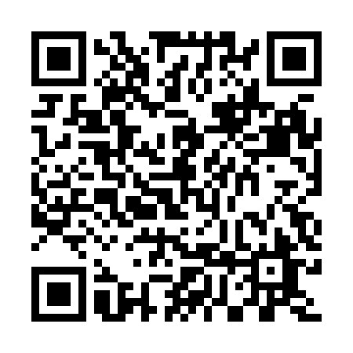
Prayer times for Unterbimbach, Germany
Mon 1 Apr 2024 - Tue 30 Apr 2024
High Latitude Method: Angle Based Rule
Prayer Calculation Method: Muslim World League
Asar Calculation Method: Shafi

Date | Day | Fajr | Sunrise | Dhuhr | Asr | Maghrib | Isha
1 | Mon | 5:01 | 6:57 | 1:25 | 4:59 | 7:55 | 9:43
2 | Tue | 4:59 | 6:55 | 1:25 | 5:00 | 7:56 | 9:46
3 | Wed | 4:56 | 6:53 | 1:25 | 5:01 | 7:58 | 9:48
4 | Thu | 4:53 | 6:50 | 1:25 | 5:01 | 8:00 | 9:50
5 | Fri | 4:50 | 6:48 | 1:24 | 5:02 | 8:01 | 9:52
6 | Sat | 4:48 | 6:46 | 1:24 | 5:03 | 8:03 | 9:54
7 | Sun | 4:45 | 6:44 | 1:24 | 5:04 | 8:04 | 9:56
8 | Mon | 4:42 | 6:42 | 1:23 | 5:05 | 8:06 | 9:58
9 | Tue | 4:39 | 6:40 | 1:23 | 5:05 | 8:08 | 10:01
10 | Wed | 4:36 | 6:38 | 1:23 | 5:06 | 8:09 | 10:03
11 | Thu | 4:33 | 6:35 | 1:23 | 5:07 | 8:11 | 10:05
12 | Fri | 4:30 | 6:33 | 1:22 | 5:08 | 8:12 | 10:07
13 | Sat | 4:28 | 6:31 | 1:22 | 5:08 | 8:14 | 10:10
14 | Sun | 4:25 | 6:29 | 1:22 | 5:09 | 8:16 | 10:12
15 | Mon | 4:22 | 6:27 | 1:22 | 5:10 | 8:17 | 10:14
16 | Tue | 4:19 | 6:25 | 1:21 | 5:11 | 8:19 | 10:17
17 | Wed | 4:16 | 6:23 | 1:21 | 5:11 | 8:20 | 10:19
18 | Thu | 4:13 | 6:21 | 1:21 | 5:12 | 8:22 | 10:22
19 | Fri | 4:10 | 6:19 | 1:21 | 5:13 | 8:24 | 10:24
20 | Sat | 4:07 | 6:17 | 1:21 | 5:14 | 8:25 | 10:27
21 | Sun | 4:04 | 6:15 | 1:20 | 5:14 | 8:27 | 10:29
22 | Mon | 4:01 | 6:13 | 1:20 | 5:15 | 8:28 | 10:32
23 | Tue | 3:58 | 6:11 | 1:20 | 5:16 | 8:30 | 10:34
24 | Wed | 3:55 | 6:09 | 1:20 | 5:16 | 8:32 | 10:37
25 | Thu | 3:51 | 6:07 | 1:20 | 5:17 | 8:33 | 10:39
26 | Fri | 3:48 | 6:05 | 1:19 | 5:18 | 8:35 | 10:42
27 | Sat | 3:45 | 6:03 | 1:19 | 5:18 | 8:36 | 10:45
28 | Sun | 3:42 | 6:01 | 1:19 | 5:19 | 8:38 | 10:48
29 | Mon | 3:39 | 5:59 | 1:19 | 5:20 | 8:40 | 10:50
30 | Tue | 3:36 | 5:57 | 1:19 | 5:20 | 8:41 | 10:53
Prayer times provided by https://www.salahtimes.com

