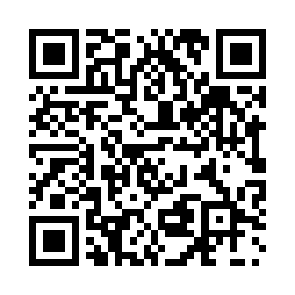
Prayer times for The Bight, Bahamas
Wed 1 May 2024 - Fri 31 May 2024
High Latitude Method: None
Prayer Calculation Method: Muslim World League
Asar Calculation Method: Shafi

Date | Day | Fajr | Sunrise | Dhuhr | Asr | Maghrib | Isha
1 | Wed | 5:05 | 6:27 | 12:59 | 4:25 | 7:31 | 8:48
2 | Thu | 5:04 | 6:26 | 12:59 | 4:25 | 7:32 | 8:48
3 | Fri | 5:04 | 6:25 | 12:58 | 4:25 | 7:32 | 8:49
4 | Sat | 5:03 | 6:24 | 12:58 | 4:25 | 7:33 | 8:50
5 | Sun | 5:02 | 6:24 | 12:58 | 4:24 | 7:33 | 8:50
6 | Mon | 5:01 | 6:23 | 12:58 | 4:24 | 7:34 | 8:51
7 | Tue | 5:00 | 6:23 | 12:58 | 4:24 | 7:34 | 8:52
8 | Wed | 4:59 | 6:22 | 12:58 | 4:24 | 7:35 | 8:52
9 | Thu | 4:59 | 6:21 | 12:58 | 4:24 | 7:35 | 8:53
10 | Fri | 4:58 | 6:21 | 12:58 | 4:23 | 7:36 | 8:54
11 | Sat | 4:57 | 6:20 | 12:58 | 4:23 | 7:36 | 8:54
12 | Sun | 4:56 | 6:20 | 12:58 | 4:23 | 7:37 | 8:55
13 | Mon | 4:56 | 6:19 | 12:58 | 4:23 | 7:37 | 8:56
14 | Tue | 4:55 | 6:19 | 12:58 | 4:23 | 7:38 | 8:56
15 | Wed | 4:54 | 6:18 | 12:58 | 4:22 | 7:38 | 8:57
16 | Thu | 4:54 | 6:18 | 12:58 | 4:22 | 7:39 | 8:58
17 | Fri | 4:53 | 6:17 | 12:58 | 4:22 | 7:39 | 8:58
18 | Sat | 4:52 | 6:17 | 12:58 | 4:22 | 7:40 | 8:59
19 | Sun | 4:52 | 6:17 | 12:58 | 4:22 | 7:40 | 9:00
20 | Mon | 4:51 | 6:16 | 12:58 | 4:22 | 7:41 | 9:00
21 | Tue | 4:51 | 6:16 | 12:58 | 4:22 | 7:41 | 9:01
22 | Wed | 4:50 | 6:15 | 12:58 | 4:21 | 7:42 | 9:02
23 | Thu | 4:50 | 6:15 | 12:58 | 4:21 | 7:42 | 9:02
24 | Fri | 4:49 | 6:15 | 12:59 | 4:21 | 7:43 | 9:03
25 | Sat | 4:49 | 6:15 | 12:59 | 4:21 | 7:43 | 9:04
26 | Sun | 4:48 | 6:14 | 12:59 | 4:21 | 7:43 | 9:04
27 | Mon | 4:48 | 6:14 | 12:59 | 4:21 | 7:44 | 9:05
28 | Tue | 4:47 | 6:14 | 12:59 | 4:21 | 7:44 | 9:06
29 | Wed | 4:47 | 6:14 | 12:59 | 4:21 | 7:45 | 9:06
30 | Thu | 4:47 | 6:14 | 12:59 | 4:21 | 7:45 | 9:07
31 | Fri | 4:46 | 6:13 | 12:59 | 4:21 | 7:46 | 9:07
Prayer times provided by https://www.salahtimes.com

