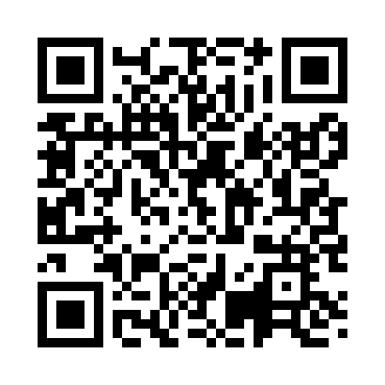
Prayer times for Sulomoisa, Estonia
Mon 1 Apr 2024 - Tue 30 Apr 2024
High Latitude Method: Angle Based Rule
Prayer Calculation Method: Muslim World League
Asar Calculation Method: Hanafi

Date | Day | Fajr | Sunrise | Dhuhr | Asr | Maghrib | Isha
1 | Mon | 4:16 | 6:41 | 1:17 | 5:41 | 7:55 | 10:10
2 | Tue | 4:12 | 6:38 | 1:17 | 5:42 | 7:57 | 10:13
3 | Wed | 4:09 | 6:35 | 1:17 | 5:44 | 7:59 | 10:16
4 | Thu | 4:05 | 6:33 | 1:16 | 5:46 | 8:01 | 10:20
5 | Fri | 4:00 | 6:30 | 1:16 | 5:47 | 8:03 | 10:23
6 | Sat | 3:56 | 6:27 | 1:16 | 5:49 | 8:06 | 10:26
7 | Sun | 3:52 | 6:24 | 1:15 | 5:50 | 8:08 | 10:30
8 | Mon | 3:48 | 6:22 | 1:15 | 5:52 | 8:10 | 10:33
9 | Tue | 3:43 | 6:19 | 1:15 | 5:54 | 8:12 | 10:37
10 | Wed | 3:39 | 6:16 | 1:15 | 5:55 | 8:14 | 10:41
11 | Thu | 3:34 | 6:13 | 1:14 | 5:57 | 8:17 | 10:44
12 | Fri | 3:30 | 6:11 | 1:14 | 5:58 | 8:19 | 10:48
13 | Sat | 3:25 | 6:08 | 1:14 | 6:00 | 8:21 | 10:52
14 | Sun | 3:20 | 6:05 | 1:14 | 6:01 | 8:23 | 10:56
15 | Mon | 3:15 | 6:03 | 1:13 | 6:03 | 8:25 | 11:01
16 | Tue | 3:10 | 6:00 | 1:13 | 6:04 | 8:28 | 11:05
17 | Wed | 3:07 | 5:57 | 1:13 | 6:05 | 8:30 | 11:09
18 | Thu | 3:06 | 5:55 | 1:13 | 6:07 | 8:32 | 11:11
19 | Fri | 3:05 | 5:52 | 1:12 | 6:08 | 8:34 | 11:12
20 | Sat | 3:03 | 5:49 | 1:12 | 6:10 | 8:36 | 11:13
21 | Sun | 3:02 | 5:47 | 1:12 | 6:11 | 8:39 | 11:14
22 | Mon | 3:01 | 5:44 | 1:12 | 6:13 | 8:41 | 11:15
23 | Tue | 3:00 | 5:42 | 1:12 | 6:14 | 8:43 | 11:16
24 | Wed | 2:59 | 5:39 | 1:11 | 6:15 | 8:45 | 11:16
25 | Thu | 2:58 | 5:36 | 1:11 | 6:17 | 8:47 | 11:17
26 | Fri | 2:57 | 5:34 | 1:11 | 6:18 | 8:50 | 11:18
27 | Sat | 2:55 | 5:31 | 1:11 | 6:20 | 8:52 | 11:19
28 | Sun | 2:54 | 5:29 | 1:11 | 6:21 | 8:54 | 11:20
29 | Mon | 2:53 | 5:26 | 1:11 | 6:22 | 8:56 | 11:21
30 | Tue | 2:52 | 5:24 | 1:11 | 6:24 | 8:58 | 11:22
Prayer times provided by https://www.salahtimes.com

