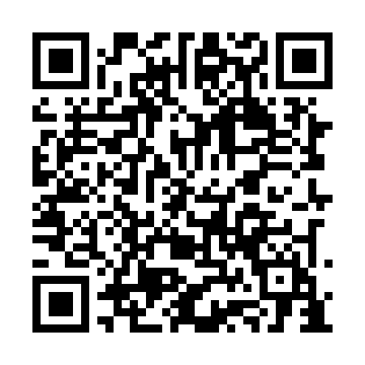
Prayer times for Char Bhumikampa, Bangladesh
Wed 1 May 2024 - Fri 31 May 2024
High Latitude Method: None
Prayer Calculation Method: University of Islamic Sciences
Asar Calculation Method: Shafi

Date | Day | Fajr | Sunrise | Dhuhr | Asr | Maghrib | Isha
1 | Wed | 4:07 | 5:28 | 11:59 | 3:25 | 6:31 | 7:52
2 | Thu | 4:06 | 5:27 | 11:59 | 3:25 | 6:31 | 7:52
3 | Fri | 4:05 | 5:26 | 11:59 | 3:24 | 6:32 | 7:53
4 | Sat | 4:04 | 5:26 | 11:59 | 3:24 | 6:32 | 7:54
5 | Sun | 4:04 | 5:25 | 11:59 | 3:24 | 6:33 | 7:54
6 | Mon | 4:03 | 5:24 | 11:59 | 3:24 | 6:33 | 7:55
7 | Tue | 4:02 | 5:24 | 11:59 | 3:23 | 6:33 | 7:56
8 | Wed | 4:01 | 5:23 | 11:58 | 3:23 | 6:34 | 7:56
9 | Thu | 4:00 | 5:23 | 11:58 | 3:23 | 6:34 | 7:57
10 | Fri | 4:00 | 5:22 | 11:58 | 3:23 | 6:35 | 7:58
11 | Sat | 3:59 | 5:22 | 11:58 | 3:22 | 6:35 | 7:58
12 | Sun | 3:58 | 5:21 | 11:58 | 3:22 | 6:36 | 7:59
13 | Mon | 3:57 | 5:21 | 11:58 | 3:22 | 6:36 | 8:00
14 | Tue | 3:57 | 5:20 | 11:58 | 3:22 | 6:37 | 8:00
15 | Wed | 3:56 | 5:20 | 11:58 | 3:22 | 6:37 | 8:01
16 | Thu | 3:55 | 5:19 | 11:58 | 3:21 | 6:38 | 8:02
17 | Fri | 3:55 | 5:19 | 11:58 | 3:21 | 6:38 | 8:02
18 | Sat | 3:54 | 5:18 | 11:58 | 3:21 | 6:39 | 8:03
19 | Sun | 3:54 | 5:18 | 11:59 | 3:21 | 6:39 | 8:04
20 | Mon | 3:53 | 5:18 | 11:59 | 3:21 | 6:40 | 8:04
21 | Tue | 3:53 | 5:17 | 11:59 | 3:21 | 6:40 | 8:05
22 | Wed | 3:52 | 5:17 | 11:59 | 3:21 | 6:41 | 8:06
23 | Thu | 3:51 | 5:17 | 11:59 | 3:20 | 6:41 | 8:06
24 | Fri | 3:51 | 5:16 | 11:59 | 3:20 | 6:42 | 8:07
25 | Sat | 3:51 | 5:16 | 11:59 | 3:20 | 6:42 | 8:08
26 | Sun | 3:50 | 5:16 | 11:59 | 3:20 | 6:43 | 8:08
27 | Mon | 3:50 | 5:15 | 11:59 | 3:20 | 6:43 | 8:09
28 | Tue | 3:49 | 5:15 | 11:59 | 3:20 | 6:44 | 8:10
29 | Wed | 3:49 | 5:15 | 11:59 | 3:20 | 6:44 | 8:10
30 | Thu | 3:49 | 5:15 | 12:00 | 3:20 | 6:45 | 8:11
31 | Fri | 3:48 | 5:15 | 12:00 | 3:20 | 6:45 | 8:11
Prayer times provided by https://www.salahtimes.com

