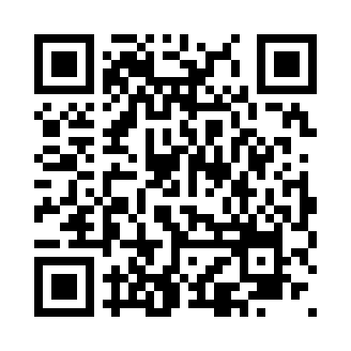
Prayer times for Bede, Manitoba, Canada
Wed 1 May 2024 - Fri 31 May 2024
High Latitude Method: Angle Based Rule
Prayer Calculation Method: Islamic Society of North America
Asar Calculation Method: Hanafi

Date | Day | Fajr | Sunrise | Dhuhr | Asr | Maghrib | Isha
1 | Wed | 4:33 | 6:21 | 1:41 | 6:46 | 9:02 | 10:50
2 | Thu | 4:30 | 6:19 | 1:41 | 6:47 | 9:03 | 10:53
3 | Fri | 4:28 | 6:17 | 1:41 | 6:48 | 9:05 | 10:55
4 | Sat | 4:25 | 6:16 | 1:41 | 6:49 | 9:06 | 10:57
5 | Sun | 4:23 | 6:14 | 1:41 | 6:50 | 9:08 | 11:00
6 | Mon | 4:20 | 6:12 | 1:40 | 6:51 | 9:09 | 11:02
7 | Tue | 4:18 | 6:11 | 1:40 | 6:51 | 9:11 | 11:04
8 | Wed | 4:15 | 6:09 | 1:40 | 6:52 | 9:12 | 11:07
9 | Thu | 4:13 | 6:08 | 1:40 | 6:53 | 9:14 | 11:09
10 | Fri | 4:10 | 6:06 | 1:40 | 6:54 | 9:15 | 11:11
11 | Sat | 4:08 | 6:05 | 1:40 | 6:55 | 9:16 | 11:14
12 | Sun | 4:06 | 6:03 | 1:40 | 6:56 | 9:18 | 11:16
13 | Mon | 4:03 | 6:02 | 1:40 | 6:57 | 9:19 | 11:19
14 | Tue | 4:01 | 6:01 | 1:40 | 6:57 | 9:21 | 11:21
15 | Wed | 3:59 | 5:59 | 1:40 | 6:58 | 9:22 | 11:23
16 | Thu | 3:56 | 5:58 | 1:40 | 6:59 | 9:23 | 11:26
17 | Fri | 3:54 | 5:57 | 1:40 | 7:00 | 9:25 | 11:28
18 | Sat | 3:52 | 5:55 | 1:40 | 7:01 | 9:26 | 11:30
19 | Sun | 3:49 | 5:54 | 1:40 | 7:01 | 9:27 | 11:33
20 | Mon | 3:47 | 5:53 | 1:40 | 7:02 | 9:29 | 11:35
21 | Tue | 3:46 | 5:52 | 1:41 | 7:03 | 9:30 | 11:35
22 | Wed | 3:46 | 5:51 | 1:41 | 7:04 | 9:31 | 11:36
23 | Thu | 3:45 | 5:50 | 1:41 | 7:04 | 9:32 | 11:37
24 | Fri | 3:45 | 5:49 | 1:41 | 7:05 | 9:33 | 11:37
25 | Sat | 3:44 | 5:48 | 1:41 | 7:06 | 9:35 | 11:38
26 | Sun | 3:44 | 5:47 | 1:41 | 7:06 | 9:36 | 11:39
27 | Mon | 3:44 | 5:46 | 1:41 | 7:07 | 9:37 | 11:39
28 | Tue | 3:43 | 5:45 | 1:41 | 7:08 | 9:38 | 11:40
29 | Wed | 3:43 | 5:44 | 1:41 | 7:08 | 9:39 | 11:40
30 | Thu | 3:43 | 5:43 | 1:42 | 7:09 | 9:40 | 11:41
31 | Fri | 3:42 | 5:43 | 1:42 | 7:10 | 9:41 | 11:42
Prayer times provided by https://www.salahtimes.com

