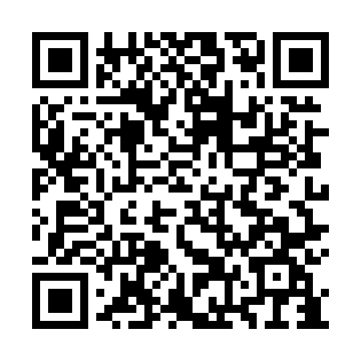
Prayer times for Hongseong County, South Korea
Wed 1 May 2024 - Fri 31 May 2024
High Latitude Method: None
Prayer Calculation Method: Muslim World League
Asar Calculation Method: Shafi

Date | Day | Fajr | Sunrise | Dhuhr | Asr | Maghrib | Isha
1 | Wed | 4:03 | 5:40 | 12:30 | 4:17 | 7:22 | 8:52
2 | Thu | 4:02 | 5:39 | 12:30 | 4:17 | 7:23 | 8:54
3 | Fri | 4:00 | 5:38 | 12:30 | 4:17 | 7:23 | 8:55
4 | Sat | 3:59 | 5:37 | 12:30 | 4:17 | 7:24 | 8:56
5 | Sun | 3:57 | 5:35 | 12:30 | 4:17 | 7:25 | 8:57
6 | Mon | 3:56 | 5:34 | 12:30 | 4:17 | 7:26 | 8:58
7 | Tue | 3:55 | 5:33 | 12:30 | 4:18 | 7:27 | 9:00
8 | Wed | 3:53 | 5:32 | 12:30 | 4:18 | 7:28 | 9:01
9 | Thu | 3:52 | 5:32 | 12:30 | 4:18 | 7:29 | 9:02
10 | Fri | 3:51 | 5:31 | 12:30 | 4:18 | 7:29 | 9:03
11 | Sat | 3:49 | 5:30 | 12:30 | 4:18 | 7:30 | 9:05
12 | Sun | 3:48 | 5:29 | 12:30 | 4:18 | 7:31 | 9:06
13 | Mon | 3:47 | 5:28 | 12:30 | 4:18 | 7:32 | 9:07
14 | Tue | 3:45 | 5:27 | 12:30 | 4:19 | 7:33 | 9:08
15 | Wed | 3:44 | 5:26 | 12:30 | 4:19 | 7:34 | 9:09
16 | Thu | 3:43 | 5:25 | 12:30 | 4:19 | 7:35 | 9:11
17 | Fri | 3:42 | 5:25 | 12:30 | 4:19 | 7:35 | 9:12
18 | Sat | 3:41 | 5:24 | 12:30 | 4:19 | 7:36 | 9:13
19 | Sun | 3:40 | 5:23 | 12:30 | 4:19 | 7:37 | 9:14
20 | Mon | 3:39 | 5:23 | 12:30 | 4:20 | 7:38 | 9:15
21 | Tue | 3:38 | 5:22 | 12:30 | 4:20 | 7:39 | 9:16
22 | Wed | 3:36 | 5:21 | 12:30 | 4:20 | 7:39 | 9:17
23 | Thu | 3:35 | 5:21 | 12:30 | 4:20 | 7:40 | 9:18
24 | Fri | 3:35 | 5:20 | 12:30 | 4:20 | 7:41 | 9:20
25 | Sat | 3:34 | 5:20 | 12:30 | 4:21 | 7:42 | 9:21
26 | Sun | 3:33 | 5:19 | 12:30 | 4:21 | 7:42 | 9:22
27 | Mon | 3:32 | 5:18 | 12:31 | 4:21 | 7:43 | 9:23
28 | Tue | 3:31 | 5:18 | 12:31 | 4:21 | 7:44 | 9:24
29 | Wed | 3:30 | 5:18 | 12:31 | 4:21 | 7:44 | 9:25
30 | Thu | 3:30 | 5:17 | 12:31 | 4:22 | 7:45 | 9:26
31 | Fri | 3:29 | 5:17 | 12:31 | 4:22 | 7:46 | 9:27
Prayer times provided by https://www.salahtimes.com

