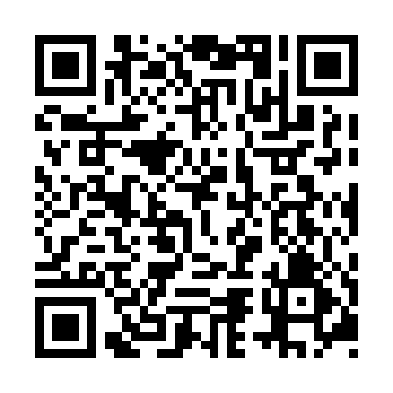
Prayer times for Coteau-des-Hetres, Quebec, Canada
Mon 1 Apr 2024 - Tue 30 Apr 2024
High Latitude Method: Angle Based Rule
Prayer Calculation Method: Islamic Society of North America
Asar Calculation Method: Hanafi

Date | Day | Fajr | Sunrise | Dhuhr | Asr | Maghrib | Isha
1 | Mon | 5:12 | 6:36 | 1:01 | 5:30 | 7:26 | 8:51
2 | Tue | 5:10 | 6:35 | 1:01 | 5:31 | 7:28 | 8:52
3 | Wed | 5:08 | 6:33 | 1:00 | 5:32 | 7:29 | 8:54
4 | Thu | 5:06 | 6:31 | 1:00 | 5:33 | 7:30 | 8:55
5 | Fri | 5:04 | 6:29 | 1:00 | 5:34 | 7:31 | 8:57
6 | Sat | 5:02 | 6:27 | 12:59 | 5:35 | 7:33 | 8:58
7 | Sun | 4:59 | 6:25 | 12:59 | 5:36 | 7:34 | 9:00
8 | Mon | 4:57 | 6:23 | 12:59 | 5:37 | 7:35 | 9:02
9 | Tue | 4:55 | 6:21 | 12:59 | 5:37 | 7:37 | 9:03
10 | Wed | 4:53 | 6:20 | 12:58 | 5:38 | 7:38 | 9:05
11 | Thu | 4:51 | 6:18 | 12:58 | 5:39 | 7:39 | 9:07
12 | Fri | 4:49 | 6:16 | 12:58 | 5:40 | 7:41 | 9:08
13 | Sat | 4:46 | 6:14 | 12:58 | 5:41 | 7:42 | 9:10
14 | Sun | 4:44 | 6:12 | 12:57 | 5:42 | 7:43 | 9:12
15 | Mon | 4:42 | 6:11 | 12:57 | 5:43 | 7:44 | 9:13
16 | Tue | 4:40 | 6:09 | 12:57 | 5:43 | 7:46 | 9:15
17 | Wed | 4:38 | 6:07 | 12:57 | 5:44 | 7:47 | 9:17
18 | Thu | 4:36 | 6:05 | 12:56 | 5:45 | 7:48 | 9:18
19 | Fri | 4:34 | 6:04 | 12:56 | 5:46 | 7:50 | 9:20
20 | Sat | 4:31 | 6:02 | 12:56 | 5:47 | 7:51 | 9:22
21 | Sun | 4:29 | 6:00 | 12:56 | 5:47 | 7:52 | 9:24
22 | Mon | 4:27 | 5:59 | 12:56 | 5:48 | 7:53 | 9:25
23 | Tue | 4:25 | 5:57 | 12:55 | 5:49 | 7:55 | 9:27
24 | Wed | 4:23 | 5:55 | 12:55 | 5:50 | 7:56 | 9:29
25 | Thu | 4:21 | 5:54 | 12:55 | 5:51 | 7:57 | 9:31
26 | Fri | 4:19 | 5:52 | 12:55 | 5:51 | 7:59 | 9:32
27 | Sat | 4:17 | 5:50 | 12:55 | 5:52 | 8:00 | 9:34
28 | Sun | 4:15 | 5:49 | 12:55 | 5:53 | 8:01 | 9:36
29 | Mon | 4:12 | 5:47 | 12:55 | 5:54 | 8:02 | 9:38
30 | Tue | 4:10 | 5:46 | 12:54 | 5:55 | 8:04 | 9:39
Prayer times provided by https://www.salahtimes.com

