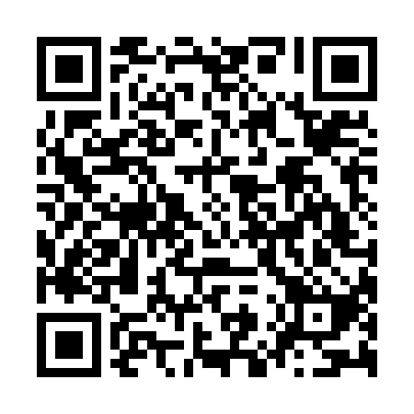
Prayer times for Bruck an der Mur, Austria
Mon 1 Apr 2024 - Tue 30 Apr 2024
High Latitude Method: Angle Based Rule
Prayer Calculation Method: Muslim World League
Asar Calculation Method: Shafi

Date | Day | Fajr | Sunrise | Dhuhr | Asr | Maghrib | Isha
1 | Mon | 4:50 | 6:37 | 1:03 | 4:37 | 7:29 | 9:10
2 | Tue | 4:48 | 6:35 | 1:02 | 4:38 | 7:30 | 9:12
3 | Wed | 4:45 | 6:33 | 1:02 | 4:38 | 7:32 | 9:13
4 | Thu | 4:43 | 6:31 | 1:02 | 4:39 | 7:33 | 9:15
5 | Fri | 4:40 | 6:29 | 1:02 | 4:40 | 7:35 | 9:17
6 | Sat | 4:38 | 6:27 | 1:01 | 4:40 | 7:36 | 9:19
7 | Sun | 4:35 | 6:25 | 1:01 | 4:41 | 7:37 | 9:21
8 | Mon | 4:33 | 6:23 | 1:01 | 4:42 | 7:39 | 9:22
9 | Tue | 4:31 | 6:21 | 1:00 | 4:42 | 7:40 | 9:24
10 | Wed | 4:28 | 6:19 | 1:00 | 4:43 | 7:42 | 9:26
11 | Thu | 4:26 | 6:17 | 1:00 | 4:44 | 7:43 | 9:28
12 | Fri | 4:23 | 6:16 | 1:00 | 4:44 | 7:44 | 9:30
13 | Sat | 4:21 | 6:14 | 12:59 | 4:45 | 7:46 | 9:32
14 | Sun | 4:18 | 6:12 | 12:59 | 4:45 | 7:47 | 9:34
15 | Mon | 4:16 | 6:10 | 12:59 | 4:46 | 7:49 | 9:36
16 | Tue | 4:13 | 6:08 | 12:59 | 4:47 | 7:50 | 9:38
17 | Wed | 4:11 | 6:06 | 12:58 | 4:47 | 7:51 | 9:40
18 | Thu | 4:08 | 6:04 | 12:58 | 4:48 | 7:53 | 9:42
19 | Fri | 4:06 | 6:02 | 12:58 | 4:48 | 7:54 | 9:44
20 | Sat | 4:03 | 6:01 | 12:58 | 4:49 | 7:56 | 9:46
21 | Sun | 4:01 | 5:59 | 12:58 | 4:50 | 7:57 | 9:48
22 | Mon | 3:58 | 5:57 | 12:57 | 4:50 | 7:58 | 9:50
23 | Tue | 3:55 | 5:55 | 12:57 | 4:51 | 8:00 | 9:52
24 | Wed | 3:53 | 5:54 | 12:57 | 4:51 | 8:01 | 9:54
25 | Thu | 3:50 | 5:52 | 12:57 | 4:52 | 8:03 | 9:56
26 | Fri | 3:48 | 5:50 | 12:57 | 4:52 | 8:04 | 9:58
27 | Sat | 3:45 | 5:48 | 12:57 | 4:53 | 8:05 | 10:01
28 | Sun | 3:43 | 5:47 | 12:56 | 4:53 | 8:07 | 10:03
29 | Mon | 3:40 | 5:45 | 12:56 | 4:54 | 8:08 | 10:05
30 | Tue | 3:38 | 5:43 | 12:56 | 4:54 | 8:10 | 10:07
Prayer times provided by https://www.salahtimes.com

