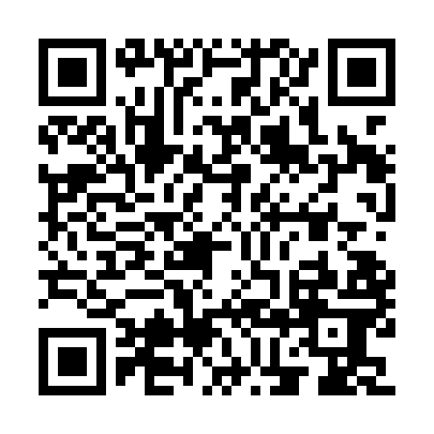
Prayer times for Char Kalir Alga, Bangladesh
Mon 1 Apr 2024 - Tue 30 Apr 2024
High Latitude Method: None
Prayer Calculation Method: University of Islamic Sciences
Asar Calculation Method: Shafi

Date | Day | Fajr | Sunrise | Dhuhr | Asr | Maghrib | Isha
1 | Mon | 4:35 | 5:52 | 12:05 | 3:34 | 6:18 | 7:35
2 | Tue | 4:33 | 5:51 | 12:04 | 3:33 | 6:18 | 7:36
3 | Wed | 4:32 | 5:50 | 12:04 | 3:33 | 6:19 | 7:36
4 | Thu | 4:31 | 5:49 | 12:04 | 3:33 | 6:19 | 7:37
5 | Fri | 4:30 | 5:48 | 12:03 | 3:33 | 6:19 | 7:38
6 | Sat | 4:29 | 5:47 | 12:03 | 3:33 | 6:20 | 7:38
7 | Sun | 4:28 | 5:46 | 12:03 | 3:33 | 6:20 | 7:39
8 | Mon | 4:26 | 5:45 | 12:03 | 3:32 | 6:21 | 7:39
9 | Tue | 4:25 | 5:44 | 12:02 | 3:32 | 6:21 | 7:40
10 | Wed | 4:24 | 5:43 | 12:02 | 3:32 | 6:22 | 7:41
11 | Thu | 4:23 | 5:42 | 12:02 | 3:32 | 6:22 | 7:41
12 | Fri | 4:22 | 5:41 | 12:02 | 3:32 | 6:23 | 7:42
13 | Sat | 4:21 | 5:40 | 12:01 | 3:31 | 6:23 | 7:42
14 | Sun | 4:20 | 5:39 | 12:01 | 3:31 | 6:24 | 7:43
15 | Mon | 4:18 | 5:38 | 12:01 | 3:31 | 6:24 | 7:44
16 | Tue | 4:17 | 5:37 | 12:01 | 3:31 | 6:25 | 7:44
17 | Wed | 4:16 | 5:36 | 12:00 | 3:31 | 6:25 | 7:45
18 | Thu | 4:15 | 5:35 | 12:00 | 3:30 | 6:26 | 7:46
19 | Fri | 4:14 | 5:34 | 12:00 | 3:30 | 6:26 | 7:46
20 | Sat | 4:13 | 5:33 | 12:00 | 3:30 | 6:27 | 7:47
21 | Sun | 4:12 | 5:32 | 12:00 | 3:30 | 6:27 | 7:48
22 | Mon | 4:11 | 5:31 | 11:59 | 3:29 | 6:28 | 7:48
23 | Tue | 4:10 | 5:30 | 11:59 | 3:29 | 6:28 | 7:49
24 | Wed | 4:09 | 5:30 | 11:59 | 3:29 | 6:29 | 7:50
25 | Thu | 4:08 | 5:29 | 11:59 | 3:29 | 6:29 | 7:50
26 | Fri | 4:07 | 5:28 | 11:59 | 3:29 | 6:30 | 7:51
27 | Sat | 4:06 | 5:27 | 11:58 | 3:28 | 6:30 | 7:52
28 | Sun | 4:04 | 5:26 | 11:58 | 3:28 | 6:31 | 7:53
29 | Mon | 4:03 | 5:26 | 11:58 | 3:28 | 6:31 | 7:53
30 | Tue | 4:03 | 5:25 | 11:58 | 3:28 | 6:32 | 7:54
Prayer times provided by https://www.salahtimes.com

