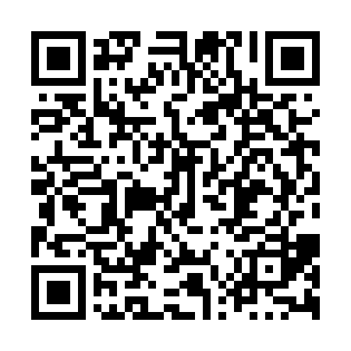
Prayer times for Harrington Harbour, Quebec, Canada
Mon 1 Apr 2024 - Tue 30 Apr 2024
High Latitude Method: Angle Based Rule
Prayer Calculation Method: Islamic Society of North America
Asar Calculation Method: Hanafi

Date | Day | Fajr | Sunrise | Dhuhr | Asr | Maghrib | Isha
1 | Mon | 3:59 | 5:33 | 12:02 | 4:29 | 6:31 | 8:05
2 | Tue | 3:56 | 5:31 | 12:01 | 4:31 | 6:33 | 8:07
3 | Wed | 3:54 | 5:29 | 12:01 | 4:32 | 6:34 | 8:09
4 | Thu | 3:51 | 5:26 | 12:01 | 4:33 | 6:36 | 8:11
5 | Fri | 3:49 | 5:24 | 12:00 | 4:34 | 6:38 | 8:13
6 | Sat | 3:46 | 5:22 | 12:00 | 4:35 | 6:39 | 8:15
7 | Sun | 3:44 | 5:20 | 12:00 | 4:36 | 6:41 | 8:17
8 | Mon | 3:41 | 5:18 | 12:00 | 4:37 | 6:42 | 8:19
9 | Tue | 3:38 | 5:16 | 11:59 | 4:39 | 6:44 | 8:22
10 | Wed | 3:36 | 5:13 | 11:59 | 4:40 | 6:46 | 8:24
11 | Thu | 3:33 | 5:11 | 11:59 | 4:41 | 6:47 | 8:26
12 | Fri | 3:30 | 5:09 | 11:59 | 4:42 | 6:49 | 8:28
13 | Sat | 3:28 | 5:07 | 11:58 | 4:43 | 6:50 | 8:30
14 | Sun | 3:25 | 5:05 | 11:58 | 4:44 | 6:52 | 8:32
15 | Mon | 3:23 | 5:03 | 11:58 | 4:45 | 6:54 | 8:34
16 | Tue | 3:20 | 5:01 | 11:58 | 4:46 | 6:55 | 8:37
17 | Wed | 3:17 | 4:59 | 11:57 | 4:47 | 6:57 | 8:39
18 | Thu | 3:15 | 4:57 | 11:57 | 4:48 | 6:58 | 8:41
19 | Fri | 3:12 | 4:55 | 11:57 | 4:49 | 7:00 | 8:43
20 | Sat | 3:09 | 4:53 | 11:57 | 4:50 | 7:02 | 8:46
21 | Sun | 3:07 | 4:51 | 11:57 | 4:51 | 7:03 | 8:48
22 | Mon | 3:04 | 4:49 | 11:56 | 4:52 | 7:05 | 8:50
23 | Tue | 3:01 | 4:47 | 11:56 | 4:53 | 7:06 | 8:52
24 | Wed | 2:58 | 4:45 | 11:56 | 4:54 | 7:08 | 8:55
25 | Thu | 2:56 | 4:43 | 11:56 | 4:55 | 7:10 | 8:57
26 | Fri | 2:53 | 4:41 | 11:56 | 4:56 | 7:11 | 9:00
27 | Sat | 2:50 | 4:39 | 11:55 | 4:57 | 7:13 | 9:02
28 | Sun | 2:48 | 4:37 | 11:55 | 4:58 | 7:14 | 9:04
29 | Mon | 2:45 | 4:35 | 11:55 | 4:59 | 7:16 | 9:07
30 | Tue | 2:42 | 4:34 | 11:55 | 5:00 | 7:17 | 9:09
Prayer times provided by https://www.salahtimes.com

