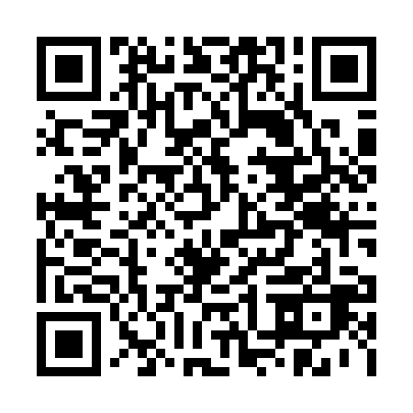
Prayer times for Anversa degli Abruzzi, Italy
Wed 1 May 2024 - Fri 31 May 2024
High Latitude Method: Angle Based Rule
Prayer Calculation Method: Muslim World League
Asar Calculation Method: Hanafi

Date | Day | Fajr | Sunrise | Dhuhr | Asr | Maghrib | Isha
1 | Wed | 4:12 | 6:00 | 1:02 | 5:59 | 8:04 | 9:46
2 | Thu | 4:10 | 5:59 | 1:02 | 6:00 | 8:05 | 9:47
3 | Fri | 4:08 | 5:58 | 1:02 | 6:00 | 8:06 | 9:49
4 | Sat | 4:06 | 5:56 | 1:02 | 6:01 | 8:07 | 9:50
5 | Sun | 4:04 | 5:55 | 1:01 | 6:01 | 8:08 | 9:52
6 | Mon | 4:03 | 5:54 | 1:01 | 6:02 | 8:09 | 9:54
7 | Tue | 4:01 | 5:53 | 1:01 | 6:03 | 8:10 | 9:55
8 | Wed | 3:59 | 5:52 | 1:01 | 6:03 | 8:12 | 9:57
9 | Thu | 3:57 | 5:50 | 1:01 | 6:04 | 8:13 | 9:58
10 | Fri | 3:55 | 5:49 | 1:01 | 6:04 | 8:14 | 10:00
11 | Sat | 3:54 | 5:48 | 1:01 | 6:05 | 8:15 | 10:02
12 | Sun | 3:52 | 5:47 | 1:01 | 6:06 | 8:16 | 10:03
13 | Mon | 3:50 | 5:46 | 1:01 | 6:06 | 8:17 | 10:05
14 | Tue | 3:49 | 5:45 | 1:01 | 6:07 | 8:18 | 10:06
15 | Wed | 3:47 | 5:44 | 1:01 | 6:07 | 8:19 | 10:08
16 | Thu | 3:45 | 5:43 | 1:01 | 6:08 | 8:20 | 10:10
17 | Fri | 3:44 | 5:42 | 1:01 | 6:09 | 8:21 | 10:11
18 | Sat | 3:42 | 5:41 | 1:01 | 6:09 | 8:22 | 10:13
19 | Sun | 3:41 | 5:40 | 1:01 | 6:10 | 8:23 | 10:14
20 | Mon | 3:39 | 5:39 | 1:01 | 6:10 | 8:24 | 10:16
21 | Tue | 3:38 | 5:39 | 1:01 | 6:11 | 8:25 | 10:17
22 | Wed | 3:36 | 5:38 | 1:02 | 6:11 | 8:26 | 10:19
23 | Thu | 3:35 | 5:37 | 1:02 | 6:12 | 8:27 | 10:20
24 | Fri | 3:34 | 5:36 | 1:02 | 6:13 | 8:27 | 10:22
25 | Sat | 3:32 | 5:36 | 1:02 | 6:13 | 8:28 | 10:23
26 | Sun | 3:31 | 5:35 | 1:02 | 6:14 | 8:29 | 10:24
27 | Mon | 3:30 | 5:34 | 1:02 | 6:14 | 8:30 | 10:26
28 | Tue | 3:29 | 5:34 | 1:02 | 6:15 | 8:31 | 10:27
29 | Wed | 3:28 | 5:33 | 1:02 | 6:15 | 8:32 | 10:28
30 | Thu | 3:27 | 5:33 | 1:02 | 6:16 | 8:33 | 10:30
31 | Fri | 3:25 | 5:32 | 1:03 | 6:16 | 8:33 | 10:31
Prayer times provided by https://www.salahtimes.com

