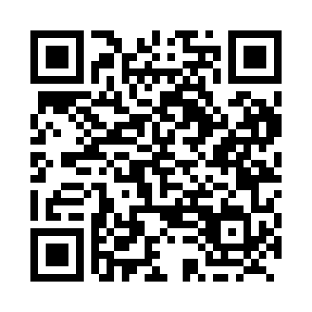
Prayer times for Alcurve, Alberta, Canada
Mon 1 Apr 2024 - Tue 30 Apr 2024
High Latitude Method: Angle Based Rule
Prayer Calculation Method: Islamic Society of North America
Asar Calculation Method: Hanafi

Date | Day | Fajr | Sunrise | Dhuhr | Asr | Maghrib | Isha
1 | Mon | 5:10 | 6:52 | 1:24 | 5:51 | 7:57 | 9:39
2 | Tue | 5:07 | 6:49 | 1:24 | 5:52 | 7:59 | 9:41
3 | Wed | 5:04 | 6:47 | 1:23 | 5:53 | 8:01 | 9:44
4 | Thu | 5:01 | 6:45 | 1:23 | 5:55 | 8:02 | 9:46
5 | Fri | 4:58 | 6:42 | 1:23 | 5:56 | 8:04 | 9:48
6 | Sat | 4:56 | 6:40 | 1:22 | 5:57 | 8:06 | 9:51
7 | Sun | 4:53 | 6:37 | 1:22 | 5:59 | 8:08 | 9:53
8 | Mon | 4:50 | 6:35 | 1:22 | 6:00 | 8:10 | 9:56
9 | Tue | 4:47 | 6:33 | 1:22 | 6:01 | 8:12 | 9:58
10 | Wed | 4:44 | 6:30 | 1:21 | 6:02 | 8:13 | 10:01
11 | Thu | 4:41 | 6:28 | 1:21 | 6:04 | 8:15 | 10:03
12 | Fri | 4:38 | 6:26 | 1:21 | 6:05 | 8:17 | 10:06
13 | Sat | 4:34 | 6:23 | 1:21 | 6:06 | 8:19 | 10:08
14 | Sun | 4:31 | 6:21 | 1:20 | 6:07 | 8:21 | 10:11
15 | Mon | 4:28 | 6:19 | 1:20 | 6:09 | 8:23 | 10:13
16 | Tue | 4:25 | 6:16 | 1:20 | 6:10 | 8:24 | 10:16
17 | Wed | 4:22 | 6:14 | 1:20 | 6:11 | 8:26 | 10:19
18 | Thu | 4:19 | 6:12 | 1:19 | 6:12 | 8:28 | 10:22
19 | Fri | 4:16 | 6:10 | 1:19 | 6:13 | 8:30 | 10:24
20 | Sat | 4:13 | 6:07 | 1:19 | 6:15 | 8:32 | 10:27
21 | Sun | 4:09 | 6:05 | 1:19 | 6:16 | 8:33 | 10:30
22 | Mon | 4:06 | 6:03 | 1:19 | 6:17 | 8:35 | 10:33
23 | Tue | 4:03 | 6:01 | 1:18 | 6:18 | 8:37 | 10:36
24 | Wed | 4:00 | 5:59 | 1:18 | 6:19 | 8:39 | 10:39
25 | Thu | 3:56 | 5:57 | 1:18 | 6:20 | 8:41 | 10:41
26 | Fri | 3:53 | 5:54 | 1:18 | 6:22 | 8:43 | 10:44
27 | Sat | 3:50 | 5:52 | 1:18 | 6:23 | 8:44 | 10:47
28 | Sun | 3:47 | 5:50 | 1:18 | 6:24 | 8:46 | 10:51
29 | Mon | 3:43 | 5:48 | 1:18 | 6:25 | 8:48 | 10:54
30 | Tue | 3:40 | 5:46 | 1:17 | 6:26 | 8:50 | 10:57
Prayer times provided by https://www.salahtimes.com

