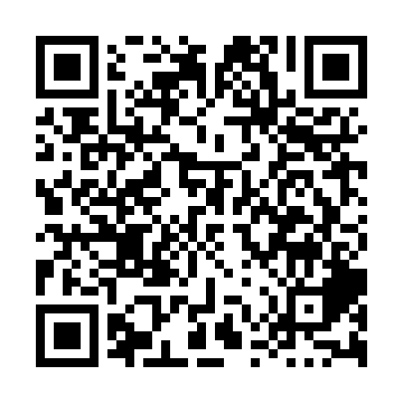
Prayer times for Hardwicke Island, British Columbia, Canada
Mon 1 Apr 2024 - Tue 30 Apr 2024
High Latitude Method: Angle Based Rule
Prayer Calculation Method: Islamic Society of North America
Asar Calculation Method: Hanafi

Date | Day | Fajr | Sunrise | Dhuhr | Asr | Maghrib | Isha
1 | Mon | 5:25 | 6:58 | 1:27 | 5:55 | 7:57 | 9:31
2 | Tue | 5:22 | 6:56 | 1:27 | 5:57 | 7:59 | 9:33
3 | Wed | 5:19 | 6:54 | 1:27 | 5:58 | 8:00 | 9:35
4 | Thu | 5:17 | 6:52 | 1:26 | 5:59 | 8:02 | 9:37
5 | Fri | 5:14 | 6:50 | 1:26 | 6:00 | 8:04 | 9:39
6 | Sat | 5:12 | 6:47 | 1:26 | 6:01 | 8:05 | 9:41
7 | Sun | 5:09 | 6:45 | 1:26 | 6:02 | 8:07 | 9:43
8 | Mon | 5:07 | 6:43 | 1:25 | 6:03 | 8:08 | 9:45
9 | Tue | 5:04 | 6:41 | 1:25 | 6:04 | 8:10 | 9:47
10 | Wed | 5:01 | 6:39 | 1:25 | 6:06 | 8:12 | 9:49
11 | Thu | 4:59 | 6:37 | 1:24 | 6:07 | 8:13 | 9:52
12 | Fri | 4:56 | 6:35 | 1:24 | 6:08 | 8:15 | 9:54
13 | Sat | 4:53 | 6:33 | 1:24 | 6:09 | 8:16 | 9:56
14 | Sun | 4:51 | 6:31 | 1:24 | 6:10 | 8:18 | 9:58
15 | Mon | 4:48 | 6:28 | 1:24 | 6:11 | 8:19 | 10:00
16 | Tue | 4:46 | 6:26 | 1:23 | 6:12 | 8:21 | 10:02
17 | Wed | 4:43 | 6:24 | 1:23 | 6:13 | 8:23 | 10:05
18 | Thu | 4:40 | 6:22 | 1:23 | 6:14 | 8:24 | 10:07
19 | Fri | 4:38 | 6:20 | 1:23 | 6:15 | 8:26 | 10:09
20 | Sat | 4:35 | 6:18 | 1:22 | 6:16 | 8:27 | 10:11
21 | Sun | 4:32 | 6:16 | 1:22 | 6:17 | 8:29 | 10:14
22 | Mon | 4:30 | 6:14 | 1:22 | 6:18 | 8:31 | 10:16
23 | Tue | 4:27 | 6:12 | 1:22 | 6:19 | 8:32 | 10:18
24 | Wed | 4:24 | 6:10 | 1:22 | 6:20 | 8:34 | 10:21
25 | Thu | 4:22 | 6:09 | 1:22 | 6:21 | 8:35 | 10:23
26 | Fri | 4:19 | 6:07 | 1:21 | 6:22 | 8:37 | 10:25
27 | Sat | 4:16 | 6:05 | 1:21 | 6:23 | 8:39 | 10:28
28 | Sun | 4:13 | 6:03 | 1:21 | 6:24 | 8:40 | 10:30
29 | Mon | 4:11 | 6:01 | 1:21 | 6:25 | 8:42 | 10:32
30 | Tue | 4:08 | 5:59 | 1:21 | 6:26 | 8:43 | 10:35
Prayer times provided by https://www.salahtimes.com

