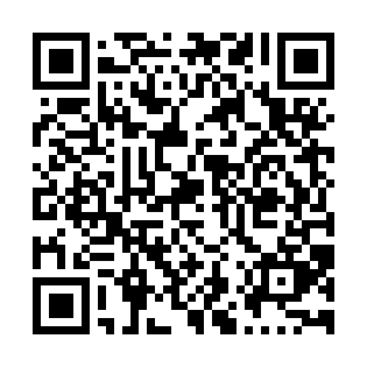
Prayer times for Saint-Leandre, Quebec, Canada
Mon 1 Jul 2024 - Wed 31 Jul 2024
High Latitude Method: Angle Based Rule
Prayer Calculation Method: Islamic Society of North America
Asar Calculation Method: Hanafi

Date | Day | Fajr | Sunrise | Dhuhr | Asr | Maghrib | Isha
1 | Mon | 2:33 | 4:32 | 12:34 | 6:04 | 8:37 | 10:35
2 | Tue | 2:34 | 4:33 | 12:35 | 6:04 | 8:36 | 10:35
3 | Wed | 2:34 | 4:33 | 12:35 | 6:04 | 8:36 | 10:35
4 | Thu | 2:34 | 4:34 | 12:35 | 6:04 | 8:36 | 10:35
5 | Fri | 2:35 | 4:35 | 12:35 | 6:04 | 8:35 | 10:35
6 | Sat | 2:35 | 4:36 | 12:35 | 6:04 | 8:35 | 10:35
7 | Sun | 2:36 | 4:37 | 12:35 | 6:03 | 8:34 | 10:35
8 | Mon | 2:36 | 4:37 | 12:36 | 6:03 | 8:33 | 10:34
9 | Tue | 2:37 | 4:38 | 12:36 | 6:03 | 8:33 | 10:34
10 | Wed | 2:37 | 4:39 | 12:36 | 6:03 | 8:32 | 10:34
11 | Thu | 2:38 | 4:40 | 12:36 | 6:02 | 8:31 | 10:34
12 | Fri | 2:39 | 4:41 | 12:36 | 6:02 | 8:31 | 10:33
13 | Sat | 2:39 | 4:42 | 12:36 | 6:02 | 8:30 | 10:33
14 | Sun | 2:40 | 4:43 | 12:36 | 6:01 | 8:29 | 10:33
15 | Mon | 2:40 | 4:44 | 12:36 | 6:01 | 8:28 | 10:32
16 | Tue | 2:41 | 4:45 | 12:37 | 6:00 | 8:27 | 10:32
17 | Wed | 2:41 | 4:46 | 12:37 | 6:00 | 8:26 | 10:31
18 | Thu | 2:42 | 4:48 | 12:37 | 5:59 | 8:25 | 10:31
19 | Fri | 2:44 | 4:49 | 12:37 | 5:59 | 8:24 | 10:29
20 | Sat | 2:46 | 4:50 | 12:37 | 5:58 | 8:23 | 10:27
21 | Sun | 2:48 | 4:51 | 12:37 | 5:58 | 8:22 | 10:25
22 | Mon | 2:50 | 4:52 | 12:37 | 5:57 | 8:21 | 10:23
23 | Tue | 2:52 | 4:53 | 12:37 | 5:56 | 8:20 | 10:20
24 | Wed | 2:54 | 4:55 | 12:37 | 5:56 | 8:19 | 10:18
25 | Thu | 2:57 | 4:56 | 12:37 | 5:55 | 8:17 | 10:16
26 | Fri | 2:59 | 4:57 | 12:37 | 5:54 | 8:16 | 10:14
27 | Sat | 3:01 | 4:58 | 12:37 | 5:53 | 8:15 | 10:12
28 | Sun | 3:03 | 5:00 | 12:37 | 5:53 | 8:13 | 10:09
29 | Mon | 3:05 | 5:01 | 12:37 | 5:52 | 8:12 | 10:07
30 | Tue | 3:08 | 5:02 | 12:37 | 5:51 | 8:11 | 10:05
31 | Wed | 3:10 | 5:04 | 12:37 | 5:50 | 8:09 | 10:02
Prayer times provided by https://www.salahtimes.com

