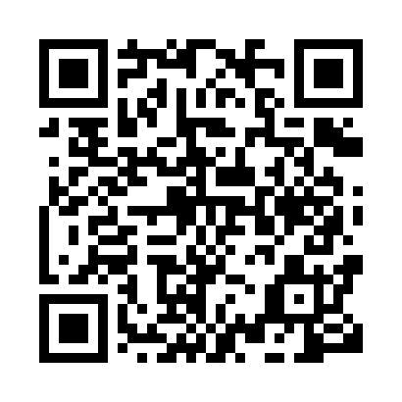
Prayer times for Bikomam, Cameroon
Mon 1 Apr 2024 - Tue 30 Apr 2024
High Latitude Method: None
Prayer Calculation Method: Muslim World League
Asar Calculation Method: Shafi

Date | Day | Fajr | Sunrise | Dhuhr | Asr | Maghrib | Isha
1 | Mon | 5:03 | 6:12 | 12:16 | 3:19 | 6:21 | 7:26
2 | Tue | 5:02 | 6:11 | 12:16 | 3:20 | 6:21 | 7:26
3 | Wed | 5:02 | 6:11 | 12:16 | 3:20 | 6:20 | 7:26
4 | Thu | 5:01 | 6:11 | 12:15 | 3:21 | 6:20 | 7:26
5 | Fri | 5:01 | 6:10 | 12:15 | 3:21 | 6:20 | 7:25
6 | Sat | 5:01 | 6:10 | 12:15 | 3:21 | 6:20 | 7:25
7 | Sun | 5:00 | 6:10 | 12:15 | 3:22 | 6:20 | 7:25
8 | Mon | 5:00 | 6:09 | 12:14 | 3:22 | 6:20 | 7:25
9 | Tue | 4:59 | 6:09 | 12:14 | 3:23 | 6:19 | 7:25
10 | Wed | 4:59 | 6:08 | 12:14 | 3:23 | 6:19 | 7:25
11 | Thu | 4:58 | 6:08 | 12:14 | 3:23 | 6:19 | 7:25
12 | Fri | 4:58 | 6:08 | 12:13 | 3:24 | 6:19 | 7:25
13 | Sat | 4:58 | 6:07 | 12:13 | 3:24 | 6:19 | 7:25
14 | Sun | 4:57 | 6:07 | 12:13 | 3:24 | 6:19 | 7:24
15 | Mon | 4:57 | 6:07 | 12:13 | 3:25 | 6:18 | 7:24
16 | Tue | 4:56 | 6:06 | 12:12 | 3:25 | 6:18 | 7:24
17 | Wed | 4:56 | 6:06 | 12:12 | 3:25 | 6:18 | 7:24
18 | Thu | 4:55 | 6:06 | 12:12 | 3:26 | 6:18 | 7:24
19 | Fri | 4:55 | 6:05 | 12:12 | 3:26 | 6:18 | 7:24
20 | Sat | 4:55 | 6:05 | 12:11 | 3:26 | 6:18 | 7:24
21 | Sun | 4:54 | 6:05 | 12:11 | 3:26 | 6:18 | 7:24
22 | Mon | 4:54 | 6:05 | 12:11 | 3:27 | 6:18 | 7:24
23 | Tue | 4:54 | 6:04 | 12:11 | 3:27 | 6:17 | 7:24
24 | Wed | 4:53 | 6:04 | 12:11 | 3:27 | 6:17 | 7:24
25 | Thu | 4:53 | 6:04 | 12:10 | 3:27 | 6:17 | 7:24
26 | Fri | 4:52 | 6:03 | 12:10 | 3:28 | 6:17 | 7:24
27 | Sat | 4:52 | 6:03 | 12:10 | 3:28 | 6:17 | 7:24
28 | Sun | 4:52 | 6:03 | 12:10 | 3:28 | 6:17 | 7:24
29 | Mon | 4:51 | 6:03 | 12:10 | 3:28 | 6:17 | 7:24
30 | Tue | 4:51 | 6:03 | 12:10 | 3:29 | 6:17 | 7:24
Prayer times provided by https://www.salahtimes.com

