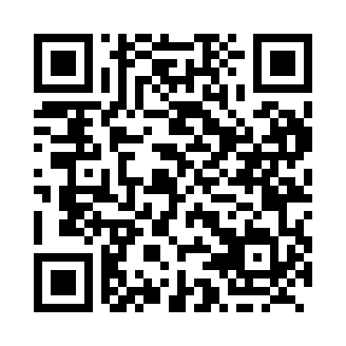
Prayer times for Davis Mills, Ontario, Canada
Mon 1 Apr 2024 - Tue 30 Apr 2024
High Latitude Method: Angle Based Rule
Prayer Calculation Method: Islamic Society of North America
Asar Calculation Method: Hanafi

Date | Day | Fajr | Sunrise | Dhuhr | Asr | Maghrib | Isha
1 | Mon | 5:23 | 6:48 | 1:12 | 5:42 | 7:38 | 9:03
2 | Tue | 5:21 | 6:46 | 1:12 | 5:43 | 7:39 | 9:04
3 | Wed | 5:19 | 6:44 | 1:12 | 5:44 | 7:41 | 9:06
4 | Thu | 5:17 | 6:42 | 1:12 | 5:45 | 7:42 | 9:07
5 | Fri | 5:15 | 6:40 | 1:11 | 5:45 | 7:43 | 9:09
6 | Sat | 5:13 | 6:38 | 1:11 | 5:46 | 7:44 | 9:11
7 | Sun | 5:10 | 6:37 | 1:11 | 5:47 | 7:46 | 9:12
8 | Mon | 5:08 | 6:35 | 1:10 | 5:48 | 7:47 | 9:14
9 | Tue | 5:06 | 6:33 | 1:10 | 5:49 | 7:48 | 9:15
10 | Wed | 5:04 | 6:31 | 1:10 | 5:50 | 7:50 | 9:17
11 | Thu | 5:02 | 6:29 | 1:10 | 5:51 | 7:51 | 9:19
12 | Fri | 5:00 | 6:27 | 1:09 | 5:52 | 7:52 | 9:20
13 | Sat | 4:57 | 6:26 | 1:09 | 5:52 | 7:54 | 9:22
14 | Sun | 4:55 | 6:24 | 1:09 | 5:53 | 7:55 | 9:24
15 | Mon | 4:53 | 6:22 | 1:09 | 5:54 | 7:56 | 9:25
16 | Tue | 4:51 | 6:20 | 1:08 | 5:55 | 7:58 | 9:27
17 | Wed | 4:49 | 6:18 | 1:08 | 5:56 | 7:59 | 9:29
18 | Thu | 4:47 | 6:17 | 1:08 | 5:57 | 8:00 | 9:30
19 | Fri | 4:44 | 6:15 | 1:08 | 5:58 | 8:01 | 9:32
20 | Sat | 4:42 | 6:13 | 1:08 | 5:58 | 8:03 | 9:34
21 | Sun | 4:40 | 6:12 | 1:07 | 5:59 | 8:04 | 9:36
22 | Mon | 4:38 | 6:10 | 1:07 | 6:00 | 8:05 | 9:37
23 | Tue | 4:36 | 6:08 | 1:07 | 6:01 | 8:07 | 9:39
24 | Wed | 4:34 | 6:06 | 1:07 | 6:02 | 8:08 | 9:41
25 | Thu | 4:32 | 6:05 | 1:07 | 6:02 | 8:09 | 9:43
26 | Fri | 4:29 | 6:03 | 1:07 | 6:03 | 8:11 | 9:45
27 | Sat | 4:27 | 6:02 | 1:06 | 6:04 | 8:12 | 9:46
28 | Sun | 4:25 | 6:00 | 1:06 | 6:05 | 8:13 | 9:48
29 | Mon | 4:23 | 5:58 | 1:06 | 6:06 | 8:14 | 9:50
30 | Tue | 4:21 | 5:57 | 1:06 | 6:06 | 8:16 | 9:52
Prayer times provided by https://www.salahtimes.com

