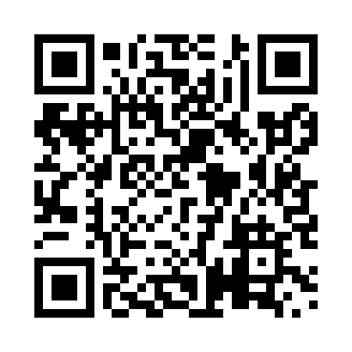
Prayer times for Twin Falls, Newfoundland and Labrador, Canada
Wed 1 May 2024 - Fri 31 May 2024
High Latitude Method: Angle Based Rule
Prayer Calculation Method: Islamic Society of North America
Asar Calculation Method: Hanafi

Date | Day | Fajr | Sunrise | Dhuhr | Asr | Maghrib | Isha
1 | Wed | 3:35 | 5:42 | 1:15 | 6:25 | 8:49 | 10:57
2 | Thu | 3:31 | 5:40 | 1:15 | 6:26 | 8:51 | 11:01
3 | Fri | 3:28 | 5:38 | 1:15 | 6:27 | 8:53 | 11:04
4 | Sat | 3:26 | 5:36 | 1:15 | 6:28 | 8:54 | 11:05
5 | Sun | 3:25 | 5:34 | 1:15 | 6:29 | 8:56 | 11:06
6 | Mon | 3:24 | 5:32 | 1:15 | 6:30 | 8:58 | 11:07
7 | Tue | 3:23 | 5:31 | 1:15 | 6:31 | 9:00 | 11:07
8 | Wed | 3:22 | 5:29 | 1:15 | 6:32 | 9:01 | 11:08
9 | Thu | 3:21 | 5:27 | 1:15 | 6:33 | 9:03 | 11:09
10 | Fri | 3:20 | 5:25 | 1:15 | 6:34 | 9:05 | 11:10
11 | Sat | 3:19 | 5:23 | 1:15 | 6:35 | 9:07 | 11:11
12 | Sun | 3:18 | 5:22 | 1:14 | 6:36 | 9:08 | 11:12
13 | Mon | 3:17 | 5:20 | 1:14 | 6:37 | 9:10 | 11:12
14 | Tue | 3:17 | 5:18 | 1:14 | 6:38 | 9:12 | 11:13
15 | Wed | 3:16 | 5:17 | 1:15 | 6:39 | 9:13 | 11:14
16 | Thu | 3:15 | 5:15 | 1:15 | 6:40 | 9:15 | 11:15
17 | Fri | 3:14 | 5:13 | 1:15 | 6:41 | 9:16 | 11:16
18 | Sat | 3:13 | 5:12 | 1:15 | 6:42 | 9:18 | 11:17
19 | Sun | 3:13 | 5:10 | 1:15 | 6:43 | 9:20 | 11:17
20 | Mon | 3:12 | 5:09 | 1:15 | 6:44 | 9:21 | 11:18
21 | Tue | 3:11 | 5:08 | 1:15 | 6:45 | 9:23 | 11:19
22 | Wed | 3:11 | 5:06 | 1:15 | 6:46 | 9:24 | 11:20
23 | Thu | 3:10 | 5:05 | 1:15 | 6:47 | 9:26 | 11:20
24 | Fri | 3:10 | 5:04 | 1:15 | 6:47 | 9:27 | 11:21
25 | Sat | 3:09 | 5:02 | 1:15 | 6:48 | 9:28 | 11:22
26 | Sun | 3:08 | 5:01 | 1:15 | 6:49 | 9:30 | 11:23
27 | Mon | 3:08 | 5:00 | 1:15 | 6:50 | 9:31 | 11:23
28 | Tue | 3:07 | 4:59 | 1:16 | 6:51 | 9:33 | 11:24
29 | Wed | 3:07 | 4:58 | 1:16 | 6:51 | 9:34 | 11:25
30 | Thu | 3:07 | 4:57 | 1:16 | 6:52 | 9:35 | 11:26
31 | Fri | 3:06 | 4:56 | 1:16 | 6:53 | 9:36 | 11:26
Prayer times provided by https://www.salahtimes.com

