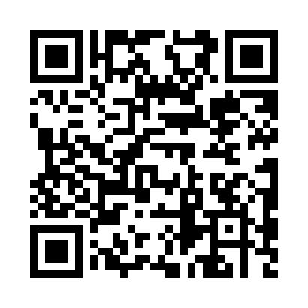
Prayer times for Sinuiju, North Korea
Mon 1 Apr 2024 - Tue 30 Apr 2024
High Latitude Method: None
Prayer Calculation Method: Muslim World League
Asar Calculation Method: Shafi

Date | Day | Fajr | Sunrise | Dhuhr | Asr | Maghrib | Isha
1 | Mon | 4:53 | 6:26 | 12:46 | 4:21 | 7:07 | 8:34
2 | Tue | 4:52 | 6:25 | 12:46 | 4:21 | 7:08 | 8:35
3 | Wed | 4:50 | 6:23 | 12:46 | 4:22 | 7:09 | 8:37
4 | Thu | 4:48 | 6:22 | 12:45 | 4:22 | 7:10 | 8:38
5 | Fri | 4:46 | 6:20 | 12:45 | 4:22 | 7:11 | 8:39
6 | Sat | 4:44 | 6:18 | 12:45 | 4:23 | 7:12 | 8:40
7 | Sun | 4:42 | 6:17 | 12:44 | 4:23 | 7:13 | 8:42
8 | Mon | 4:40 | 6:15 | 12:44 | 4:23 | 7:14 | 8:43
9 | Tue | 4:39 | 6:14 | 12:44 | 4:24 | 7:15 | 8:44
10 | Wed | 4:37 | 6:12 | 12:44 | 4:24 | 7:16 | 8:46
11 | Thu | 4:35 | 6:11 | 12:43 | 4:24 | 7:17 | 8:47
12 | Fri | 4:33 | 6:09 | 12:43 | 4:25 | 7:18 | 8:48
13 | Sat | 4:31 | 6:07 | 12:43 | 4:25 | 7:19 | 8:50
14 | Sun | 4:29 | 6:06 | 12:43 | 4:25 | 7:20 | 8:51
15 | Mon | 4:27 | 6:04 | 12:42 | 4:26 | 7:21 | 8:52
16 | Tue | 4:26 | 6:03 | 12:42 | 4:26 | 7:22 | 8:54
17 | Wed | 4:24 | 6:01 | 12:42 | 4:26 | 7:23 | 8:55
18 | Thu | 4:22 | 6:00 | 12:42 | 4:27 | 7:24 | 8:56
19 | Fri | 4:20 | 5:59 | 12:42 | 4:27 | 7:25 | 8:58
20 | Sat | 4:18 | 5:57 | 12:41 | 4:27 | 7:26 | 8:59
21 | Sun | 4:16 | 5:56 | 12:41 | 4:27 | 7:27 | 9:00
22 | Mon | 4:15 | 5:54 | 12:41 | 4:28 | 7:28 | 9:02
23 | Tue | 4:13 | 5:53 | 12:41 | 4:28 | 7:29 | 9:03
24 | Wed | 4:11 | 5:51 | 12:41 | 4:28 | 7:30 | 9:05
25 | Thu | 4:09 | 5:50 | 12:40 | 4:28 | 7:31 | 9:06
26 | Fri | 4:07 | 5:49 | 12:40 | 4:29 | 7:32 | 9:07
27 | Sat | 4:06 | 5:47 | 12:40 | 4:29 | 7:33 | 9:09
28 | Sun | 4:04 | 5:46 | 12:40 | 4:29 | 7:34 | 9:10
29 | Mon | 4:02 | 5:45 | 12:40 | 4:30 | 7:35 | 9:12
30 | Tue | 4:00 | 5:43 | 12:40 | 4:30 | 7:36 | 9:13
Prayer times provided by https://www.salahtimes.com

