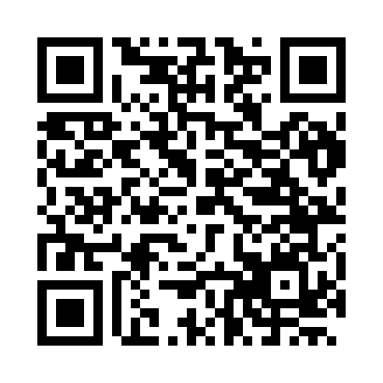
Prayer times for Loisieux, France
Wed 1 May 2024 - Fri 31 May 2024
High Latitude Method: Angle Based Rule
Prayer Calculation Method: Islamic Organisations Union of France
Asar Calculation Method: Shafi

Date | Day | Fajr | Sunrise | Dhuhr | Asr | Maghrib | Isha
1 | Wed | 5:10 | 6:24 | 1:34 | 5:31 | 8:45 | 9:59
2 | Thu | 5:09 | 6:23 | 1:34 | 5:32 | 8:46 | 10:00
3 | Fri | 5:07 | 6:21 | 1:34 | 5:32 | 8:47 | 10:02
4 | Sat | 5:05 | 6:20 | 1:34 | 5:32 | 8:48 | 10:04
5 | Sun | 5:03 | 6:18 | 1:34 | 5:33 | 8:50 | 10:05
6 | Mon | 5:01 | 6:17 | 1:34 | 5:33 | 8:51 | 10:07
7 | Tue | 5:00 | 6:16 | 1:34 | 5:34 | 8:52 | 10:09
8 | Wed | 4:58 | 6:14 | 1:34 | 5:34 | 8:53 | 10:10
9 | Thu | 4:56 | 6:13 | 1:33 | 5:35 | 8:55 | 10:12
10 | Fri | 4:54 | 6:12 | 1:33 | 5:35 | 8:56 | 10:13
11 | Sat | 4:53 | 6:10 | 1:33 | 5:35 | 8:57 | 10:15
12 | Sun | 4:51 | 6:09 | 1:33 | 5:36 | 8:58 | 10:17
13 | Mon | 4:49 | 6:08 | 1:33 | 5:36 | 9:00 | 10:18
14 | Tue | 4:48 | 6:07 | 1:33 | 5:37 | 9:01 | 10:20
15 | Wed | 4:46 | 6:06 | 1:33 | 5:37 | 9:02 | 10:21
16 | Thu | 4:45 | 6:04 | 1:33 | 5:38 | 9:03 | 10:23
17 | Fri | 4:43 | 6:03 | 1:33 | 5:38 | 9:04 | 10:25
18 | Sat | 4:42 | 6:02 | 1:34 | 5:38 | 9:05 | 10:26
19 | Sun | 4:40 | 6:01 | 1:34 | 5:39 | 9:06 | 10:28
20 | Mon | 4:39 | 6:00 | 1:34 | 5:39 | 9:08 | 10:29
21 | Tue | 4:38 | 5:59 | 1:34 | 5:40 | 9:09 | 10:31
22 | Wed | 4:36 | 5:58 | 1:34 | 5:40 | 9:10 | 10:32
23 | Thu | 4:35 | 5:57 | 1:34 | 5:40 | 9:11 | 10:34
24 | Fri | 4:34 | 5:57 | 1:34 | 5:41 | 9:12 | 10:35
25 | Sat | 4:32 | 5:56 | 1:34 | 5:41 | 9:13 | 10:36
26 | Sun | 4:31 | 5:55 | 1:34 | 5:42 | 9:14 | 10:38
27 | Mon | 4:30 | 5:54 | 1:34 | 5:42 | 9:15 | 10:39
28 | Tue | 4:29 | 5:53 | 1:34 | 5:42 | 9:16 | 10:40
29 | Wed | 4:28 | 5:53 | 1:35 | 5:43 | 9:17 | 10:42
30 | Thu | 4:27 | 5:52 | 1:35 | 5:43 | 9:18 | 10:43
31 | Fri | 4:26 | 5:52 | 1:35 | 5:43 | 9:19 | 10:44
Prayer times provided by https://www.salahtimes.com

