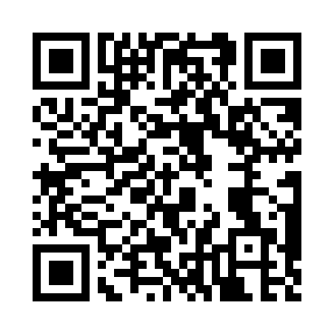
Prayer times for Bacchus, North Carolina, USA
Mon 1 Jul 2024 - Wed 31 Jul 2024
High Latitude Method: Angle Based Rule
Prayer Calculation Method: Islamic Society of North America
Asar Calculation Method: Shafi

Date | Day | Fajr | Sunrise | Dhuhr | Asr | Maghrib | Isha
1 | Mon | 4:49 | 6:16 | 1:33 | 5:22 | 8:49 | 10:17
2 | Tue | 4:49 | 6:17 | 1:33 | 5:23 | 8:49 | 10:16
3 | Wed | 4:50 | 6:17 | 1:33 | 5:23 | 8:49 | 10:16
4 | Thu | 4:51 | 6:18 | 1:33 | 5:23 | 8:49 | 10:16
5 | Fri | 4:51 | 6:18 | 1:34 | 5:23 | 8:49 | 10:15
6 | Sat | 4:52 | 6:19 | 1:34 | 5:23 | 8:49 | 10:15
7 | Sun | 4:53 | 6:19 | 1:34 | 5:23 | 8:48 | 10:15
8 | Mon | 4:54 | 6:20 | 1:34 | 5:23 | 8:48 | 10:14
9 | Tue | 4:54 | 6:20 | 1:34 | 5:24 | 8:48 | 10:14
10 | Wed | 4:55 | 6:21 | 1:34 | 5:24 | 8:47 | 10:13
11 | Thu | 4:56 | 6:22 | 1:34 | 5:24 | 8:47 | 10:13
12 | Fri | 4:57 | 6:22 | 1:35 | 5:24 | 8:47 | 10:12
13 | Sat | 4:58 | 6:23 | 1:35 | 5:24 | 8:46 | 10:11
14 | Sun | 4:59 | 6:24 | 1:35 | 5:24 | 8:46 | 10:11
15 | Mon | 4:59 | 6:24 | 1:35 | 5:24 | 8:45 | 10:10
16 | Tue | 5:00 | 6:25 | 1:35 | 5:24 | 8:45 | 10:09
17 | Wed | 5:01 | 6:26 | 1:35 | 5:24 | 8:44 | 10:08
18 | Thu | 5:02 | 6:26 | 1:35 | 5:24 | 8:44 | 10:08
19 | Fri | 5:03 | 6:27 | 1:35 | 5:24 | 8:43 | 10:07
20 | Sat | 5:04 | 6:28 | 1:35 | 5:24 | 8:42 | 10:06
21 | Sun | 5:05 | 6:28 | 1:35 | 5:24 | 8:42 | 10:05
22 | Mon | 5:06 | 6:29 | 1:35 | 5:24 | 8:41 | 10:04
23 | Tue | 5:07 | 6:30 | 1:35 | 5:24 | 8:40 | 10:03
24 | Wed | 5:08 | 6:31 | 1:35 | 5:24 | 8:40 | 10:02
25 | Thu | 5:09 | 6:31 | 1:35 | 5:23 | 8:39 | 10:01
26 | Fri | 5:10 | 6:32 | 1:35 | 5:23 | 8:38 | 10:00
27 | Sat | 5:11 | 6:33 | 1:35 | 5:23 | 8:37 | 9:59
28 | Sun | 5:12 | 6:34 | 1:35 | 5:23 | 8:37 | 9:58
29 | Mon | 5:13 | 6:34 | 1:35 | 5:23 | 8:36 | 9:57
30 | Tue | 5:14 | 6:35 | 1:35 | 5:23 | 8:35 | 9:56
31 | Wed | 5:15 | 6:36 | 1:35 | 5:22 | 8:34 | 9:54
Prayer times provided by https://www.salahtimes.com

