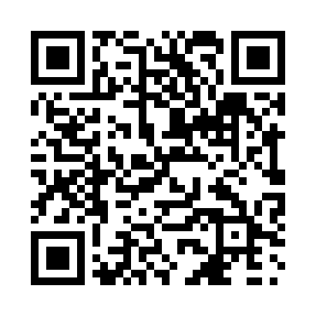
Prayer times for Baie-Laval, Quebec, Canada
Wed 1 May 2024 - Fri 31 May 2024
High Latitude Method: Angle Based Rule
Prayer Calculation Method: Islamic Society of North America
Asar Calculation Method: Hanafi

Date | Day | Fajr | Sunrise | Dhuhr | Asr | Maghrib | Isha
1 | Wed | 3:29 | 5:15 | 12:33 | 5:38 | 7:52 | 9:38
2 | Thu | 3:27 | 5:13 | 12:33 | 5:39 | 7:54 | 9:41
3 | Fri | 3:25 | 5:12 | 12:33 | 5:39 | 7:55 | 9:43
4 | Sat | 3:22 | 5:10 | 12:33 | 5:40 | 7:57 | 9:45
5 | Sun | 3:20 | 5:08 | 12:33 | 5:41 | 7:58 | 9:47
6 | Mon | 3:17 | 5:07 | 12:33 | 5:42 | 7:59 | 9:49
7 | Tue | 3:15 | 5:05 | 12:33 | 5:43 | 8:01 | 9:52
8 | Wed | 3:13 | 5:04 | 12:33 | 5:44 | 8:02 | 9:54
9 | Thu | 3:10 | 5:02 | 12:33 | 5:45 | 8:04 | 9:56
10 | Fri | 3:08 | 5:01 | 12:33 | 5:45 | 8:05 | 9:58
11 | Sat | 3:06 | 4:59 | 12:33 | 5:46 | 8:06 | 10:01
12 | Sun | 3:03 | 4:58 | 12:33 | 5:47 | 8:08 | 10:03
13 | Mon | 3:01 | 4:57 | 12:33 | 5:48 | 8:09 | 10:05
14 | Tue | 2:59 | 4:55 | 12:33 | 5:49 | 8:11 | 10:08
15 | Wed | 2:57 | 4:54 | 12:33 | 5:49 | 8:12 | 10:10
16 | Thu | 2:54 | 4:53 | 12:33 | 5:50 | 8:13 | 10:12
17 | Fri | 2:52 | 4:51 | 12:33 | 5:51 | 8:14 | 10:14
18 | Sat | 2:50 | 4:50 | 12:33 | 5:52 | 8:16 | 10:17
19 | Sun | 2:48 | 4:49 | 12:33 | 5:53 | 8:17 | 10:19
20 | Mon | 2:46 | 4:48 | 12:33 | 5:53 | 8:18 | 10:21
21 | Tue | 2:44 | 4:47 | 12:33 | 5:54 | 8:20 | 10:23
22 | Wed | 2:42 | 4:46 | 12:33 | 5:55 | 8:21 | 10:25
23 | Thu | 2:40 | 4:45 | 12:33 | 5:55 | 8:22 | 10:28
24 | Fri | 2:39 | 4:44 | 12:33 | 5:56 | 8:23 | 10:28
25 | Sat | 2:38 | 4:43 | 12:33 | 5:57 | 8:24 | 10:29
26 | Sun | 2:38 | 4:42 | 12:33 | 5:58 | 8:25 | 10:29
27 | Mon | 2:37 | 4:41 | 12:33 | 5:58 | 8:26 | 10:30
28 | Tue | 2:37 | 4:40 | 12:34 | 5:59 | 8:28 | 10:31
29 | Wed | 2:37 | 4:39 | 12:34 | 5:59 | 8:29 | 10:31
30 | Thu | 2:36 | 4:39 | 12:34 | 6:00 | 8:30 | 10:32
31 | Fri | 2:36 | 4:38 | 12:34 | 6:01 | 8:31 | 10:32
Prayer times provided by https://www.salahtimes.com

