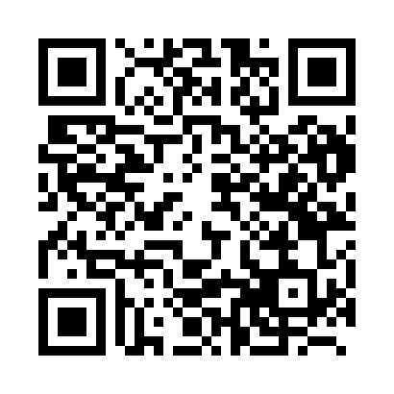
Prayer times for Banneux, Belgium
Wed 1 May 2024 - Fri 31 May 2024
High Latitude Method: Angle Based Rule
Prayer Calculation Method: Muslim World League
Asar Calculation Method: Shafi

Date | Day | Fajr | Sunrise | Dhuhr | Asr | Maghrib | Isha
1 | Wed | 3:48 | 6:11 | 1:34 | 5:36 | 8:58 | 11:11
2 | Thu | 3:45 | 6:09 | 1:34 | 5:37 | 9:00 | 11:14
3 | Fri | 3:41 | 6:08 | 1:34 | 5:37 | 9:01 | 11:17
4 | Sat | 3:38 | 6:06 | 1:34 | 5:38 | 9:03 | 11:20
5 | Sun | 3:35 | 6:04 | 1:34 | 5:39 | 9:04 | 11:23
6 | Mon | 3:31 | 6:02 | 1:34 | 5:39 | 9:06 | 11:26
7 | Tue | 3:28 | 6:01 | 1:34 | 5:40 | 9:07 | 11:29
8 | Wed | 3:24 | 5:59 | 1:34 | 5:40 | 9:09 | 11:32
9 | Thu | 3:21 | 5:57 | 1:33 | 5:41 | 9:10 | 11:35
10 | Fri | 3:19 | 5:56 | 1:33 | 5:42 | 9:12 | 11:38
11 | Sat | 3:18 | 5:54 | 1:33 | 5:42 | 9:13 | 11:41
12 | Sun | 3:17 | 5:53 | 1:33 | 5:43 | 9:15 | 11:42
13 | Mon | 3:17 | 5:51 | 1:33 | 5:43 | 9:16 | 11:42
14 | Tue | 3:16 | 5:50 | 1:33 | 5:44 | 9:18 | 11:43
15 | Wed | 3:16 | 5:48 | 1:33 | 5:44 | 9:19 | 11:43
16 | Thu | 3:15 | 5:47 | 1:33 | 5:45 | 9:21 | 11:44
17 | Fri | 3:15 | 5:46 | 1:33 | 5:46 | 9:22 | 11:45
18 | Sat | 3:14 | 5:44 | 1:34 | 5:46 | 9:23 | 11:45
19 | Sun | 3:14 | 5:43 | 1:34 | 5:47 | 9:25 | 11:46
20 | Mon | 3:13 | 5:42 | 1:34 | 5:47 | 9:26 | 11:47
21 | Tue | 3:13 | 5:41 | 1:34 | 5:48 | 9:27 | 11:47
22 | Wed | 3:12 | 5:39 | 1:34 | 5:48 | 9:29 | 11:48
23 | Thu | 3:12 | 5:38 | 1:34 | 5:49 | 9:30 | 11:48
24 | Fri | 3:11 | 5:37 | 1:34 | 5:49 | 9:31 | 11:49
25 | Sat | 3:11 | 5:36 | 1:34 | 5:50 | 9:32 | 11:50
26 | Sun | 3:11 | 5:35 | 1:34 | 5:50 | 9:34 | 11:50
27 | Mon | 3:10 | 5:34 | 1:34 | 5:51 | 9:35 | 11:51
28 | Tue | 3:10 | 5:33 | 1:34 | 5:51 | 9:36 | 11:51
29 | Wed | 3:10 | 5:32 | 1:35 | 5:52 | 9:37 | 11:52
30 | Thu | 3:10 | 5:32 | 1:35 | 5:52 | 9:38 | 11:52
31 | Fri | 3:09 | 5:31 | 1:35 | 5:53 | 9:39 | 11:53
Prayer times provided by https://www.salahtimes.com

