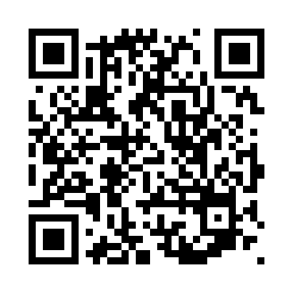
Prayer times for Beko, Cameroon
Mon 1 Apr 2024 - Tue 30 Apr 2024
High Latitude Method: None
Prayer Calculation Method: Muslim World League
Asar Calculation Method: Shafi

Date | Day | Fajr | Sunrise | Dhuhr | Asr | Maghrib | Isha
1 | Mon | 5:12 | 6:21 | 12:26 | 3:28 | 6:31 | 7:36
2 | Tue | 5:11 | 6:21 | 12:26 | 3:27 | 6:31 | 7:36
3 | Wed | 5:11 | 6:20 | 12:26 | 3:27 | 6:31 | 7:36
4 | Thu | 5:10 | 6:20 | 12:25 | 3:28 | 6:31 | 7:36
5 | Fri | 5:10 | 6:19 | 12:25 | 3:28 | 6:31 | 7:36
6 | Sat | 5:09 | 6:19 | 12:25 | 3:29 | 6:30 | 7:36
7 | Sun | 5:09 | 6:18 | 12:24 | 3:29 | 6:30 | 7:36
8 | Mon | 5:08 | 6:18 | 12:24 | 3:30 | 6:30 | 7:36
9 | Tue | 5:08 | 6:18 | 12:24 | 3:30 | 6:30 | 7:36
10 | Wed | 5:07 | 6:17 | 12:24 | 3:30 | 6:30 | 7:36
11 | Thu | 5:07 | 6:17 | 12:23 | 3:31 | 6:30 | 7:36
12 | Fri | 5:06 | 6:16 | 12:23 | 3:31 | 6:30 | 7:36
13 | Sat | 5:06 | 6:16 | 12:23 | 3:32 | 6:30 | 7:36
14 | Sun | 5:06 | 6:16 | 12:23 | 3:32 | 6:29 | 7:36
15 | Mon | 5:05 | 6:15 | 12:22 | 3:32 | 6:29 | 7:36
16 | Tue | 5:05 | 6:15 | 12:22 | 3:33 | 6:29 | 7:36
17 | Wed | 5:04 | 6:15 | 12:22 | 3:33 | 6:29 | 7:36
18 | Thu | 5:04 | 6:14 | 12:22 | 3:34 | 6:29 | 7:36
19 | Fri | 5:03 | 6:14 | 12:21 | 3:34 | 6:29 | 7:36
20 | Sat | 5:03 | 6:13 | 12:21 | 3:34 | 6:29 | 7:36
21 | Sun | 5:02 | 6:13 | 12:21 | 3:35 | 6:29 | 7:36
22 | Mon | 5:02 | 6:13 | 12:21 | 3:35 | 6:29 | 7:36
23 | Tue | 5:01 | 6:13 | 12:21 | 3:35 | 6:29 | 7:36
24 | Wed | 5:01 | 6:12 | 12:20 | 3:36 | 6:29 | 7:36
25 | Thu | 5:01 | 6:12 | 12:20 | 3:36 | 6:29 | 7:36
26 | Fri | 5:00 | 6:12 | 12:20 | 3:36 | 6:29 | 7:36
27 | Sat | 5:00 | 6:11 | 12:20 | 3:36 | 6:29 | 7:36
28 | Sun | 4:59 | 6:11 | 12:20 | 3:37 | 6:29 | 7:36
29 | Mon | 4:59 | 6:11 | 12:20 | 3:37 | 6:29 | 7:36
30 | Tue | 4:59 | 6:11 | 12:20 | 3:37 | 6:29 | 7:36
Prayer times provided by https://www.salahtimes.com

