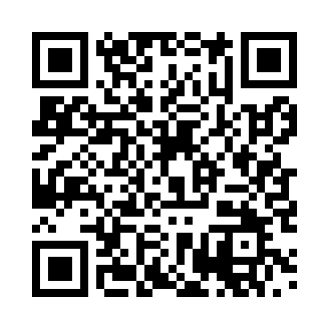
Prayer times for Unkenbach, Germany
Mon 1 Apr 2024 - Tue 30 Apr 2024
High Latitude Method: Angle Based Rule
Prayer Calculation Method: Muslim World League
Asar Calculation Method: Shafi

Date | Day | Fajr | Sunrise | Dhuhr | Asr | Maghrib | Isha
1 | Mon | 5:12 | 7:05 | 1:33 | 5:07 | 8:01 | 9:48
2 | Tue | 5:09 | 7:03 | 1:32 | 5:07 | 8:03 | 9:50
3 | Wed | 5:07 | 7:01 | 1:32 | 5:08 | 8:04 | 9:52
4 | Thu | 5:04 | 6:59 | 1:32 | 5:09 | 8:06 | 9:54
5 | Fri | 5:01 | 6:57 | 1:32 | 5:10 | 8:07 | 9:56
6 | Sat | 4:59 | 6:55 | 1:31 | 5:10 | 8:09 | 9:58
7 | Sun | 4:56 | 6:52 | 1:31 | 5:11 | 8:11 | 10:00
8 | Mon | 4:53 | 6:50 | 1:31 | 5:12 | 8:12 | 10:02
9 | Tue | 4:50 | 6:48 | 1:30 | 5:13 | 8:14 | 10:04
10 | Wed | 4:48 | 6:46 | 1:30 | 5:13 | 8:15 | 10:06
11 | Thu | 4:45 | 6:44 | 1:30 | 5:14 | 8:17 | 10:08
12 | Fri | 4:42 | 6:42 | 1:30 | 5:15 | 8:18 | 10:11
13 | Sat | 4:39 | 6:40 | 1:29 | 5:16 | 8:20 | 10:13
14 | Sun | 4:37 | 6:38 | 1:29 | 5:16 | 8:21 | 10:15
15 | Mon | 4:34 | 6:36 | 1:29 | 5:17 | 8:23 | 10:17
16 | Tue | 4:31 | 6:34 | 1:29 | 5:18 | 8:24 | 10:19
17 | Wed | 4:28 | 6:32 | 1:28 | 5:18 | 8:26 | 10:22
18 | Thu | 4:25 | 6:30 | 1:28 | 5:19 | 8:28 | 10:24
19 | Fri | 4:23 | 6:28 | 1:28 | 5:20 | 8:29 | 10:26
20 | Sat | 4:20 | 6:26 | 1:28 | 5:20 | 8:31 | 10:29
21 | Sun | 4:17 | 6:24 | 1:28 | 5:21 | 8:32 | 10:31
22 | Mon | 4:14 | 6:22 | 1:27 | 5:22 | 8:34 | 10:33
23 | Tue | 4:11 | 6:20 | 1:27 | 5:22 | 8:35 | 10:36
24 | Wed | 4:08 | 6:18 | 1:27 | 5:23 | 8:37 | 10:38
25 | Thu | 4:05 | 6:16 | 1:27 | 5:24 | 8:38 | 10:41
26 | Fri | 4:02 | 6:14 | 1:27 | 5:24 | 8:40 | 10:43
27 | Sat | 3:59 | 6:13 | 1:27 | 5:25 | 8:41 | 10:46
28 | Sun | 3:56 | 6:11 | 1:26 | 5:25 | 8:43 | 10:48
29 | Mon | 3:53 | 6:09 | 1:26 | 5:26 | 8:44 | 10:51
30 | Tue | 3:50 | 6:07 | 1:26 | 5:27 | 8:46 | 10:53
Prayer times provided by https://www.salahtimes.com

