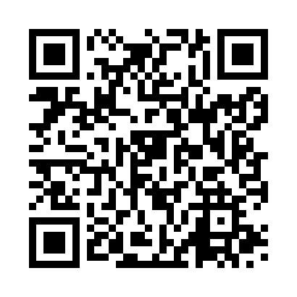
Prayer times for Mqabba, Malta
Wed 1 May 2024 - Fri 31 May 2024
High Latitude Method: None
Prayer Calculation Method: Muslim World League
Asar Calculation Method: Shafi

Date | Day | Fajr | Sunrise | Dhuhr | Asr | Maghrib | Isha
1 | Wed | 4:34 | 6:10 | 12:59 | 4:44 | 7:49 | 9:19
2 | Thu | 4:33 | 6:08 | 12:59 | 4:45 | 7:50 | 9:20
3 | Fri | 4:31 | 6:07 | 12:59 | 4:45 | 7:51 | 9:21
4 | Sat | 4:30 | 6:06 | 12:59 | 4:45 | 7:52 | 9:22
5 | Sun | 4:29 | 6:05 | 12:59 | 4:45 | 7:53 | 9:24
6 | Mon | 4:27 | 6:04 | 12:59 | 4:45 | 7:54 | 9:25
7 | Tue | 4:26 | 6:03 | 12:59 | 4:45 | 7:54 | 9:26
8 | Wed | 4:25 | 6:02 | 12:59 | 4:45 | 7:55 | 9:27
9 | Thu | 4:23 | 6:02 | 12:59 | 4:45 | 7:56 | 9:28
10 | Fri | 4:22 | 6:01 | 12:59 | 4:46 | 7:57 | 9:29
11 | Sat | 4:21 | 6:00 | 12:59 | 4:46 | 7:58 | 9:31
12 | Sun | 4:20 | 5:59 | 12:58 | 4:46 | 7:59 | 9:32
13 | Mon | 4:18 | 5:58 | 12:58 | 4:46 | 7:59 | 9:33
14 | Tue | 4:17 | 5:57 | 12:58 | 4:46 | 8:00 | 9:34
15 | Wed | 4:16 | 5:56 | 12:59 | 4:46 | 8:01 | 9:35
16 | Thu | 4:15 | 5:56 | 12:59 | 4:46 | 8:02 | 9:36
17 | Fri | 4:14 | 5:55 | 12:59 | 4:47 | 8:03 | 9:37
18 | Sat | 4:13 | 5:54 | 12:59 | 4:47 | 8:03 | 9:39
19 | Sun | 4:12 | 5:54 | 12:59 | 4:47 | 8:04 | 9:40
20 | Mon | 4:11 | 5:53 | 12:59 | 4:47 | 8:05 | 9:41
21 | Tue | 4:10 | 5:52 | 12:59 | 4:47 | 8:06 | 9:42
22 | Wed | 4:09 | 5:52 | 12:59 | 4:47 | 8:06 | 9:43
23 | Thu | 4:08 | 5:51 | 12:59 | 4:47 | 8:07 | 9:44
24 | Fri | 4:07 | 5:51 | 12:59 | 4:48 | 8:08 | 9:45
25 | Sat | 4:06 | 5:50 | 12:59 | 4:48 | 8:09 | 9:46
26 | Sun | 4:05 | 5:50 | 12:59 | 4:48 | 8:09 | 9:47
27 | Mon | 4:04 | 5:49 | 12:59 | 4:48 | 8:10 | 9:48
28 | Tue | 4:03 | 5:49 | 12:59 | 4:48 | 8:11 | 9:49
29 | Wed | 4:03 | 5:48 | 1:00 | 4:49 | 8:11 | 9:50
30 | Thu | 4:02 | 5:48 | 1:00 | 4:49 | 8:12 | 9:51
31 | Fri | 4:01 | 5:47 | 1:00 | 4:49 | 8:13 | 9:52
Prayer times provided by https://www.salahtimes.com

