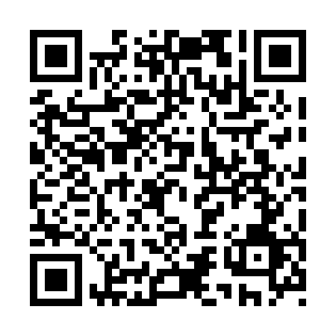
Prayer times for Tasiqanngituq, Quebec, Canada
Mon 1 Jul 2024 - Wed 31 Jul 2024
High Latitude Method: Angle Based Rule
Prayer Calculation Method: Islamic Society of North America
Asar Calculation Method: Hanafi

Date | Day | Fajr | Sunrise | Dhuhr | Asr | Maghrib | Isha
1 | Mon | 2:31 | 3:57 | 1:06 | 7:02 | 10:16 | 11:41
2 | Tue | 2:32 | 3:58 | 1:07 | 7:01 | 10:15 | 11:41
3 | Wed | 2:33 | 3:59 | 1:07 | 7:01 | 10:14 | 11:40
4 | Thu | 2:33 | 4:00 | 1:07 | 7:01 | 10:13 | 11:40
5 | Fri | 2:34 | 4:01 | 1:07 | 7:01 | 10:12 | 11:39
6 | Sat | 2:35 | 4:03 | 1:07 | 7:00 | 10:11 | 11:39
7 | Sun | 2:36 | 4:04 | 1:07 | 7:00 | 10:10 | 11:39
8 | Mon | 2:36 | 4:05 | 1:08 | 6:59 | 10:09 | 11:38
9 | Tue | 2:37 | 4:07 | 1:08 | 6:59 | 10:08 | 11:37
10 | Wed | 2:38 | 4:09 | 1:08 | 6:58 | 10:06 | 11:37
11 | Thu | 2:39 | 4:10 | 1:08 | 6:58 | 10:05 | 11:36
12 | Fri | 2:40 | 4:12 | 1:08 | 6:57 | 10:04 | 11:36
13 | Sat | 2:41 | 4:13 | 1:08 | 6:56 | 10:02 | 11:35
14 | Sun | 2:42 | 4:15 | 1:08 | 6:56 | 10:01 | 11:34
15 | Mon | 2:42 | 4:17 | 1:08 | 6:55 | 9:59 | 11:33
16 | Tue | 2:43 | 4:19 | 1:08 | 6:54 | 9:57 | 11:33
17 | Wed | 2:44 | 4:21 | 1:09 | 6:53 | 9:56 | 11:32
18 | Thu | 2:45 | 4:23 | 1:09 | 6:53 | 9:54 | 11:31
19 | Fri | 2:46 | 4:24 | 1:09 | 6:52 | 9:52 | 11:30
20 | Sat | 2:47 | 4:26 | 1:09 | 6:51 | 9:50 | 11:29
21 | Sun | 2:48 | 4:28 | 1:09 | 6:50 | 9:48 | 11:28
22 | Mon | 2:49 | 4:30 | 1:09 | 6:49 | 9:46 | 11:27
23 | Tue | 2:50 | 4:32 | 1:09 | 6:48 | 9:44 | 11:26
24 | Wed | 2:51 | 4:34 | 1:09 | 6:47 | 9:42 | 11:25
25 | Thu | 2:52 | 4:37 | 1:09 | 6:46 | 9:40 | 11:24
26 | Fri | 2:53 | 4:39 | 1:09 | 6:45 | 9:38 | 11:23
27 | Sat | 2:55 | 4:41 | 1:09 | 6:43 | 9:36 | 11:22
28 | Sun | 2:56 | 4:43 | 1:09 | 6:42 | 9:34 | 11:21
29 | Mon | 2:57 | 4:45 | 1:09 | 6:41 | 9:31 | 11:20
30 | Tue | 2:58 | 4:47 | 1:09 | 6:40 | 9:29 | 11:19
31 | Wed | 2:59 | 4:49 | 1:09 | 6:38 | 9:27 | 11:17
Prayer times provided by https://www.salahtimes.com

