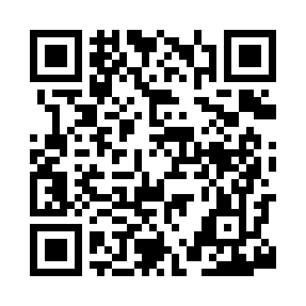
Prayer times for Broad Cove, Maine, USA
Mon 1 Jul 2024 - Wed 31 Jul 2024
High Latitude Method: Angle Based Rule
Prayer Calculation Method: Islamic Society of North America
Asar Calculation Method: Shafi

Date | Day | Fajr | Sunrise | Dhuhr | Asr | Maghrib | Isha
1 | Mon | 3:08 | 4:59 | 12:42 | 4:48 | 8:24 | 10:15
2 | Tue | 3:09 | 4:59 | 12:42 | 4:49 | 8:24 | 10:14
3 | Wed | 3:10 | 5:00 | 12:42 | 4:49 | 8:24 | 10:14
4 | Thu | 3:11 | 5:01 | 12:42 | 4:49 | 8:24 | 10:13
5 | Fri | 3:12 | 5:01 | 12:42 | 4:49 | 8:23 | 10:13
6 | Sat | 3:13 | 5:02 | 12:43 | 4:49 | 8:23 | 10:12
7 | Sun | 3:14 | 5:03 | 12:43 | 4:49 | 8:22 | 10:11
8 | Mon | 3:15 | 5:03 | 12:43 | 4:49 | 8:22 | 10:10
9 | Tue | 3:16 | 5:04 | 12:43 | 4:49 | 8:22 | 10:09
10 | Wed | 3:17 | 5:05 | 12:43 | 4:49 | 8:21 | 10:08
11 | Thu | 3:19 | 5:06 | 12:43 | 4:49 | 8:20 | 10:07
12 | Fri | 3:20 | 5:07 | 12:43 | 4:49 | 8:20 | 10:06
13 | Sat | 3:21 | 5:07 | 12:44 | 4:49 | 8:19 | 10:05
14 | Sun | 3:22 | 5:08 | 12:44 | 4:48 | 8:19 | 10:04
15 | Mon | 3:24 | 5:09 | 12:44 | 4:48 | 8:18 | 10:03
16 | Tue | 3:25 | 5:10 | 12:44 | 4:48 | 8:17 | 10:02
17 | Wed | 3:27 | 5:11 | 12:44 | 4:48 | 8:16 | 10:01
18 | Thu | 3:28 | 5:12 | 12:44 | 4:48 | 8:16 | 9:59
19 | Fri | 3:29 | 5:13 | 12:44 | 4:48 | 8:15 | 9:58
20 | Sat | 3:31 | 5:14 | 12:44 | 4:47 | 8:14 | 9:56
21 | Sun | 3:32 | 5:15 | 12:44 | 4:47 | 8:13 | 9:55
22 | Mon | 3:34 | 5:16 | 12:44 | 4:47 | 8:12 | 9:54
23 | Tue | 3:35 | 5:17 | 12:44 | 4:47 | 8:11 | 9:52
24 | Wed | 3:37 | 5:18 | 12:44 | 4:46 | 8:10 | 9:51
25 | Thu | 3:39 | 5:19 | 12:44 | 4:46 | 8:09 | 9:49
26 | Fri | 3:40 | 5:20 | 12:44 | 4:46 | 8:08 | 9:47
27 | Sat | 3:42 | 5:21 | 12:44 | 4:45 | 8:07 | 9:46
28 | Sun | 3:43 | 5:22 | 12:44 | 4:45 | 8:06 | 9:44
29 | Mon | 3:45 | 5:23 | 12:44 | 4:45 | 8:05 | 9:43
30 | Tue | 3:46 | 5:24 | 12:44 | 4:44 | 8:03 | 9:41
31 | Wed | 3:48 | 5:25 | 12:44 | 4:44 | 8:02 | 9:39
Prayer times provided by https://www.salahtimes.com

