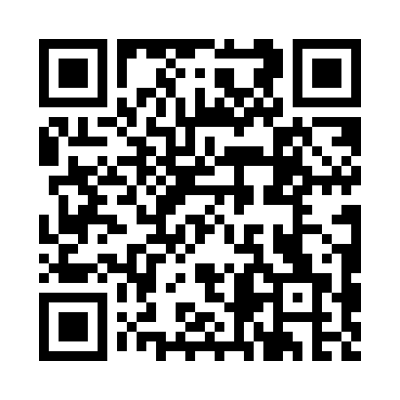
Prayer times for Chillum Station, Washington DC, USA
Wed 1 May 2024 - Fri 31 May 2024
High Latitude Method: Angle Based Rule
Prayer Calculation Method: Islamic Society of North America
Asar Calculation Method: Shafi

Date | Day | Fajr | Sunrise | Dhuhr | Asr | Maghrib | Isha
1 | Wed | 4:47 | 6:09 | 1:05 | 4:54 | 8:01 | 9:24
2 | Thu | 4:46 | 6:08 | 1:05 | 4:55 | 8:02 | 9:25
3 | Fri | 4:44 | 6:07 | 1:05 | 4:55 | 8:03 | 9:26
4 | Sat | 4:43 | 6:06 | 1:05 | 4:55 | 8:04 | 9:28
5 | Sun | 4:41 | 6:05 | 1:05 | 4:55 | 8:05 | 9:29
6 | Mon | 4:40 | 6:04 | 1:05 | 4:56 | 8:06 | 9:30
7 | Tue | 4:38 | 6:03 | 1:05 | 4:56 | 8:07 | 9:31
8 | Wed | 4:37 | 6:02 | 1:04 | 4:56 | 8:08 | 9:33
9 | Thu | 4:36 | 6:01 | 1:04 | 4:56 | 8:09 | 9:34
10 | Fri | 4:34 | 6:00 | 1:04 | 4:56 | 8:10 | 9:35
11 | Sat | 4:33 | 5:59 | 1:04 | 4:57 | 8:11 | 9:37
12 | Sun | 4:32 | 5:58 | 1:04 | 4:57 | 8:12 | 9:38
13 | Mon | 4:30 | 5:57 | 1:04 | 4:57 | 8:13 | 9:39
14 | Tue | 4:29 | 5:56 | 1:04 | 4:57 | 8:13 | 9:40
15 | Wed | 4:28 | 5:55 | 1:04 | 4:58 | 8:14 | 9:42
16 | Thu | 4:27 | 5:54 | 1:04 | 4:58 | 8:15 | 9:43
17 | Fri | 4:26 | 5:53 | 1:04 | 4:58 | 8:16 | 9:44
18 | Sat | 4:24 | 5:52 | 1:04 | 4:58 | 8:17 | 9:45
19 | Sun | 4:23 | 5:52 | 1:05 | 4:58 | 8:18 | 9:46
20 | Mon | 4:22 | 5:51 | 1:05 | 4:59 | 8:19 | 9:48
21 | Tue | 4:21 | 5:50 | 1:05 | 4:59 | 8:20 | 9:49
22 | Wed | 4:20 | 5:49 | 1:05 | 4:59 | 8:20 | 9:50
23 | Thu | 4:19 | 5:49 | 1:05 | 4:59 | 8:21 | 9:51
24 | Fri | 4:18 | 5:48 | 1:05 | 5:00 | 8:22 | 9:52
25 | Sat | 4:17 | 5:48 | 1:05 | 5:00 | 8:23 | 9:53
26 | Sun | 4:16 | 5:47 | 1:05 | 5:00 | 8:24 | 9:54
27 | Mon | 4:16 | 5:46 | 1:05 | 5:00 | 8:24 | 9:55
28 | Tue | 4:15 | 5:46 | 1:05 | 5:01 | 8:25 | 9:57
29 | Wed | 4:14 | 5:45 | 1:06 | 5:01 | 8:26 | 9:58
30 | Thu | 4:13 | 5:45 | 1:06 | 5:01 | 8:27 | 9:59
31 | Fri | 4:13 | 5:45 | 1:06 | 5:01 | 8:27 | 10:00
Prayer times provided by https://www.salahtimes.com

