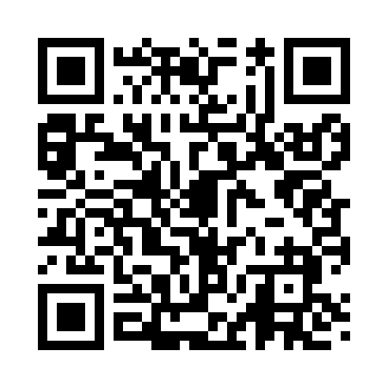
Prayer times for Schlomer, Washington, USA
Mon 1 Jul 2024 - Wed 31 Jul 2024
High Latitude Method: Angle Based Rule
Prayer Calculation Method: Islamic Society of North America
Asar Calculation Method: Shafi

Date | Day | Fajr | Sunrise | Dhuhr | Asr | Maghrib | Isha
1 | Mon | 3:03 | 5:06 | 1:00 | 5:12 | 8:53 | 10:56
2 | Tue | 3:03 | 5:07 | 1:00 | 5:12 | 8:53 | 10:56
3 | Wed | 3:04 | 5:08 | 1:00 | 5:12 | 8:52 | 10:56
4 | Thu | 3:05 | 5:08 | 1:00 | 5:12 | 8:52 | 10:55
5 | Fri | 3:06 | 5:09 | 1:00 | 5:12 | 8:52 | 10:54
6 | Sat | 3:08 | 5:10 | 1:01 | 5:12 | 8:51 | 10:53
7 | Sun | 3:09 | 5:11 | 1:01 | 5:12 | 8:51 | 10:52
8 | Mon | 3:10 | 5:11 | 1:01 | 5:12 | 8:50 | 10:51
9 | Tue | 3:12 | 5:12 | 1:01 | 5:12 | 8:50 | 10:50
10 | Wed | 3:13 | 5:13 | 1:01 | 5:12 | 8:49 | 10:49
11 | Thu | 3:15 | 5:14 | 1:01 | 5:12 | 8:48 | 10:47
12 | Fri | 3:16 | 5:15 | 1:01 | 5:12 | 8:48 | 10:46
13 | Sat | 3:18 | 5:16 | 1:02 | 5:11 | 8:47 | 10:45
14 | Sun | 3:19 | 5:17 | 1:02 | 5:11 | 8:46 | 10:43
15 | Mon | 3:21 | 5:18 | 1:02 | 5:11 | 8:45 | 10:42
16 | Tue | 3:23 | 5:19 | 1:02 | 5:11 | 8:44 | 10:40
17 | Wed | 3:24 | 5:20 | 1:02 | 5:11 | 8:44 | 10:39
18 | Thu | 3:26 | 5:21 | 1:02 | 5:10 | 8:43 | 10:37
19 | Fri | 3:28 | 5:22 | 1:02 | 5:10 | 8:42 | 10:35
20 | Sat | 3:30 | 5:23 | 1:02 | 5:10 | 8:41 | 10:34
21 | Sun | 3:32 | 5:24 | 1:02 | 5:10 | 8:40 | 10:32
22 | Mon | 3:33 | 5:25 | 1:02 | 5:09 | 8:39 | 10:30
23 | Tue | 3:35 | 5:26 | 1:02 | 5:09 | 8:38 | 10:28
24 | Wed | 3:37 | 5:27 | 1:02 | 5:09 | 8:36 | 10:26
25 | Thu | 3:39 | 5:29 | 1:02 | 5:08 | 8:35 | 10:25
26 | Fri | 3:41 | 5:30 | 1:02 | 5:08 | 8:34 | 10:23
27 | Sat | 3:43 | 5:31 | 1:02 | 5:07 | 8:33 | 10:21
28 | Sun | 3:45 | 5:32 | 1:02 | 5:07 | 8:32 | 10:19
29 | Mon | 3:46 | 5:33 | 1:02 | 5:06 | 8:30 | 10:17
30 | Tue | 3:48 | 5:35 | 1:02 | 5:06 | 8:29 | 10:15
31 | Wed | 3:50 | 5:36 | 1:02 | 5:05 | 8:28 | 10:13
Prayer times provided by https://www.salahtimes.com

