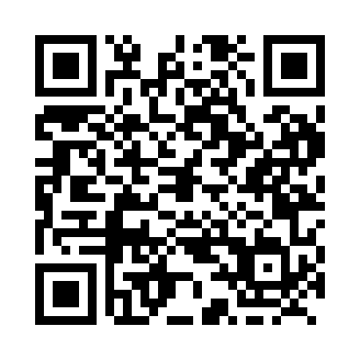
Prayer times for Altario, Alberta, Canada
Mon 1 Jul 2024 - Wed 31 Jul 2024
High Latitude Method: Angle Based Rule
Prayer Calculation Method: Islamic Society of North America
Asar Calculation Method: Hanafi

Date | Day | Fajr | Sunrise | Dhuhr | Asr | Maghrib | Isha
1 | Mon | 3:15 | 5:06 | 1:25 | 7:02 | 9:43 | 11:34
2 | Tue | 3:16 | 5:07 | 1:25 | 7:02 | 9:43 | 11:34
3 | Wed | 3:16 | 5:08 | 1:25 | 7:01 | 9:42 | 11:34
4 | Thu | 3:17 | 5:08 | 1:25 | 7:01 | 9:42 | 11:33
5 | Fri | 3:17 | 5:09 | 1:25 | 7:01 | 9:41 | 11:33
6 | Sat | 3:18 | 5:10 | 1:26 | 7:01 | 9:41 | 11:33
7 | Sun | 3:18 | 5:11 | 1:26 | 7:01 | 9:40 | 11:33
8 | Mon | 3:19 | 5:12 | 1:26 | 7:00 | 9:39 | 11:32
9 | Tue | 3:20 | 5:13 | 1:26 | 7:00 | 9:38 | 11:32
10 | Wed | 3:20 | 5:14 | 1:26 | 7:00 | 9:38 | 11:32
11 | Thu | 3:21 | 5:15 | 1:26 | 6:59 | 9:37 | 11:31
12 | Fri | 3:21 | 5:16 | 1:26 | 6:59 | 9:36 | 11:31
13 | Sat | 3:22 | 5:18 | 1:27 | 6:58 | 9:35 | 11:31
14 | Sun | 3:23 | 5:19 | 1:27 | 6:58 | 9:34 | 11:30
15 | Mon | 3:23 | 5:20 | 1:27 | 6:57 | 9:33 | 11:30
16 | Tue | 3:24 | 5:21 | 1:27 | 6:57 | 9:32 | 11:29
17 | Wed | 3:25 | 5:23 | 1:27 | 6:56 | 9:31 | 11:29
18 | Thu | 3:25 | 5:24 | 1:27 | 6:56 | 9:29 | 11:28
19 | Fri | 3:26 | 5:25 | 1:27 | 6:55 | 9:28 | 11:28
20 | Sat | 3:27 | 5:26 | 1:27 | 6:54 | 9:27 | 11:27
21 | Sun | 3:27 | 5:28 | 1:27 | 6:54 | 9:26 | 11:26
22 | Mon | 3:28 | 5:29 | 1:27 | 6:53 | 9:24 | 11:26
23 | Tue | 3:29 | 5:31 | 1:27 | 6:52 | 9:23 | 11:25
24 | Wed | 3:29 | 5:32 | 1:27 | 6:51 | 9:22 | 11:24
25 | Thu | 3:30 | 5:33 | 1:27 | 6:50 | 9:20 | 11:24
26 | Fri | 3:31 | 5:35 | 1:27 | 6:50 | 9:19 | 11:23
27 | Sat | 3:32 | 5:36 | 1:27 | 6:49 | 9:17 | 11:22
28 | Sun | 3:32 | 5:38 | 1:27 | 6:48 | 9:16 | 11:21
29 | Mon | 3:33 | 5:39 | 1:27 | 6:47 | 9:14 | 11:20
30 | Tue | 3:34 | 5:41 | 1:27 | 6:46 | 9:12 | 11:20
31 | Wed | 3:35 | 5:42 | 1:27 | 6:45 | 9:11 | 11:19
Prayer times provided by https://www.salahtimes.com

