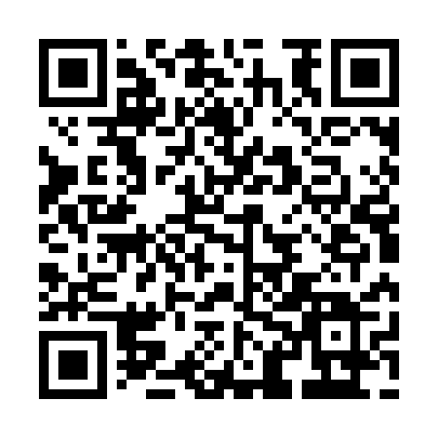
Prayer times for Chinook Valley, Alberta, Canada
Wed 1 May 2024 - Fri 31 May 2024
High Latitude Method: Angle Based Rule
Prayer Calculation Method: Islamic Society of North America
Asar Calculation Method: Hanafi

Date | Day | Fajr | Sunrise | Dhuhr | Asr | Maghrib | Isha
1 | Wed | 3:56 | 6:03 | 1:48 | 7:01 | 9:33 | 11:41
2 | Thu | 3:54 | 6:01 | 1:48 | 7:02 | 9:36 | 11:42
3 | Fri | 3:53 | 5:58 | 1:47 | 7:04 | 9:38 | 11:43
4 | Sat | 3:52 | 5:56 | 1:47 | 7:05 | 9:40 | 11:44
5 | Sun | 3:51 | 5:54 | 1:47 | 7:06 | 9:42 | 11:45
6 | Mon | 3:50 | 5:52 | 1:47 | 7:07 | 9:44 | 11:46
7 | Tue | 3:49 | 5:50 | 1:47 | 7:08 | 9:46 | 11:47
8 | Wed | 3:48 | 5:48 | 1:47 | 7:10 | 9:48 | 11:48
9 | Thu | 3:47 | 5:45 | 1:47 | 7:11 | 9:50 | 11:49
10 | Fri | 3:45 | 5:43 | 1:47 | 7:12 | 9:52 | 11:50
11 | Sat | 3:44 | 5:41 | 1:47 | 7:13 | 9:54 | 11:51
12 | Sun | 3:43 | 5:39 | 1:47 | 7:14 | 9:56 | 11:52
13 | Mon | 3:42 | 5:37 | 1:47 | 7:15 | 9:58 | 11:53
14 | Tue | 3:42 | 5:36 | 1:47 | 7:16 | 9:59 | 11:53
15 | Wed | 3:41 | 5:34 | 1:47 | 7:17 | 10:01 | 11:54
16 | Thu | 3:40 | 5:32 | 1:47 | 7:19 | 10:03 | 11:55
17 | Fri | 3:39 | 5:30 | 1:47 | 7:20 | 10:05 | 11:56
18 | Sat | 3:38 | 5:28 | 1:47 | 7:21 | 10:07 | 11:57
19 | Sun | 3:37 | 5:27 | 1:47 | 7:22 | 10:09 | 11:58
20 | Mon | 3:36 | 5:25 | 1:47 | 7:23 | 10:11 | 11:59
21 | Tue | 3:35 | 5:23 | 1:47 | 7:24 | 10:12 | 12:00
22 | Wed | 3:35 | 5:22 | 1:47 | 7:25 | 10:14 | 12:01
23 | Thu | 3:34 | 5:20 | 1:47 | 7:26 | 10:16 | 12:02
24 | Fri | 3:33 | 5:19 | 1:48 | 7:27 | 10:17 | 12:03
25 | Sat | 3:33 | 5:17 | 1:48 | 7:27 | 10:19 | 12:04
26 | Sun | 3:32 | 5:16 | 1:48 | 7:28 | 10:21 | 12:04
27 | Mon | 3:31 | 5:14 | 1:48 | 7:29 | 10:22 | 12:05
28 | Tue | 3:31 | 5:13 | 1:48 | 7:30 | 10:24 | 12:06
29 | Wed | 3:30 | 5:12 | 1:48 | 7:31 | 10:25 | 12:07
30 | Thu | 3:30 | 5:11 | 1:48 | 7:32 | 10:27 | 12:08
31 | Fri | 3:29 | 5:09 | 1:48 | 7:32 | 10:28 | 12:08
Prayer times provided by https://www.salahtimes.com

