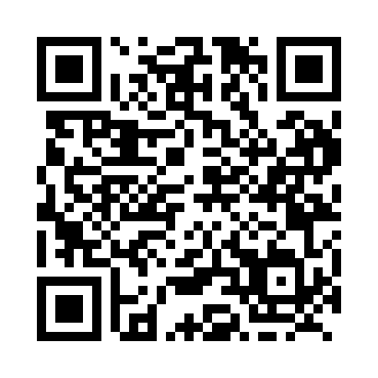
Prayer times for Glenbank, British Columbia, Canada
Mon 1 Apr 2024 - Tue 30 Apr 2024
High Latitude Method: Angle Based Rule
Prayer Calculation Method: Islamic Society of North America
Asar Calculation Method: Hanafi

Date | Day | Fajr | Sunrise | Dhuhr | Asr | Maghrib | Isha
1 | Mon | 4:53 | 6:26 | 12:55 | 5:23 | 7:24 | 8:58
2 | Tue | 4:50 | 6:24 | 12:55 | 5:24 | 7:26 | 9:00
3 | Wed | 4:48 | 6:22 | 12:54 | 5:25 | 7:28 | 9:02
4 | Thu | 4:45 | 6:20 | 12:54 | 5:26 | 7:29 | 9:04
5 | Fri | 4:43 | 6:17 | 12:54 | 5:28 | 7:31 | 9:06
6 | Sat | 4:40 | 6:15 | 12:53 | 5:29 | 7:32 | 9:08
7 | Sun | 4:37 | 6:13 | 12:53 | 5:30 | 7:34 | 9:10
8 | Mon | 4:35 | 6:11 | 12:53 | 5:31 | 7:36 | 9:12
9 | Tue | 4:32 | 6:09 | 12:53 | 5:32 | 7:37 | 9:14
10 | Wed | 4:30 | 6:07 | 12:52 | 5:33 | 7:39 | 9:16
11 | Thu | 4:27 | 6:05 | 12:52 | 5:34 | 7:40 | 9:18
12 | Fri | 4:24 | 6:03 | 12:52 | 5:35 | 7:42 | 9:20
13 | Sat | 4:22 | 6:00 | 12:52 | 5:36 | 7:43 | 9:23
14 | Sun | 4:19 | 5:58 | 12:51 | 5:37 | 7:45 | 9:25
15 | Mon | 4:17 | 5:56 | 12:51 | 5:38 | 7:47 | 9:27
16 | Tue | 4:14 | 5:54 | 12:51 | 5:39 | 7:48 | 9:29
17 | Wed | 4:11 | 5:52 | 12:51 | 5:40 | 7:50 | 9:31
18 | Thu | 4:09 | 5:50 | 12:50 | 5:42 | 7:51 | 9:33
19 | Fri | 4:06 | 5:48 | 12:50 | 5:43 | 7:53 | 9:36
20 | Sat | 4:03 | 5:46 | 12:50 | 5:44 | 7:55 | 9:38
21 | Sun | 4:01 | 5:44 | 12:50 | 5:45 | 7:56 | 9:40
22 | Mon | 3:58 | 5:42 | 12:50 | 5:46 | 7:58 | 9:42
23 | Tue | 3:55 | 5:40 | 12:49 | 5:47 | 7:59 | 9:45
24 | Wed | 3:53 | 5:38 | 12:49 | 5:48 | 8:01 | 9:47
25 | Thu | 3:50 | 5:37 | 12:49 | 5:49 | 8:02 | 9:49
26 | Fri | 3:47 | 5:35 | 12:49 | 5:50 | 8:04 | 9:52
27 | Sat | 3:45 | 5:33 | 12:49 | 5:51 | 8:06 | 9:54
28 | Sun | 3:42 | 5:31 | 12:49 | 5:52 | 8:07 | 9:56
29 | Mon | 3:40 | 5:29 | 12:48 | 5:53 | 8:09 | 9:59
30 | Tue | 3:37 | 5:27 | 12:48 | 5:53 | 8:10 | 10:01
Prayer times provided by https://www.salahtimes.com

