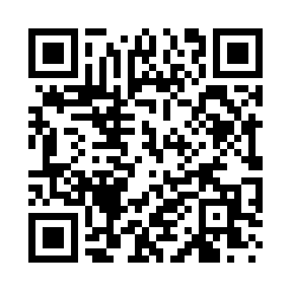
Prayer times for Corcys, Utah, USA
Wed 1 May 2024 - Fri 31 May 2024
High Latitude Method: Angle Based Rule
Prayer Calculation Method: Islamic Society of North America
Asar Calculation Method: Shafi

Date | Day | Fajr | Sunrise | Dhuhr | Asr | Maghrib | Isha
1 | Wed | 4:58 | 6:25 | 1:25 | 5:17 | 8:26 | 9:52
2 | Thu | 4:57 | 6:23 | 1:25 | 5:17 | 8:27 | 9:54
3 | Fri | 4:55 | 6:22 | 1:25 | 5:18 | 8:28 | 9:55
4 | Sat | 4:53 | 6:21 | 1:25 | 5:18 | 8:29 | 9:56
5 | Sun | 4:52 | 6:20 | 1:24 | 5:18 | 8:30 | 9:58
6 | Mon | 4:50 | 6:18 | 1:24 | 5:18 | 8:31 | 9:59
7 | Tue | 4:49 | 6:17 | 1:24 | 5:19 | 8:32 | 10:01
8 | Wed | 4:47 | 6:16 | 1:24 | 5:19 | 8:33 | 10:02
9 | Thu | 4:46 | 6:15 | 1:24 | 5:19 | 8:34 | 10:04
10 | Fri | 4:44 | 6:14 | 1:24 | 5:20 | 8:35 | 10:05
11 | Sat | 4:43 | 6:13 | 1:24 | 5:20 | 8:36 | 10:07
12 | Sun | 4:41 | 6:12 | 1:24 | 5:20 | 8:37 | 10:08
13 | Mon | 4:40 | 6:11 | 1:24 | 5:20 | 8:38 | 10:09
14 | Tue | 4:38 | 6:10 | 1:24 | 5:21 | 8:39 | 10:11
15 | Wed | 4:37 | 6:09 | 1:24 | 5:21 | 8:40 | 10:12
16 | Thu | 4:36 | 6:08 | 1:24 | 5:21 | 8:41 | 10:14
17 | Fri | 4:34 | 6:07 | 1:24 | 5:22 | 8:42 | 10:15
18 | Sat | 4:33 | 6:06 | 1:24 | 5:22 | 8:43 | 10:16
19 | Sun | 4:32 | 6:05 | 1:24 | 5:22 | 8:44 | 10:18
20 | Mon | 4:31 | 6:04 | 1:24 | 5:23 | 8:45 | 10:19
21 | Tue | 4:29 | 6:04 | 1:24 | 5:23 | 8:46 | 10:20
22 | Wed | 4:28 | 6:03 | 1:25 | 5:23 | 8:47 | 10:22
23 | Thu | 4:27 | 6:02 | 1:25 | 5:23 | 8:48 | 10:23
24 | Fri | 4:26 | 6:01 | 1:25 | 5:24 | 8:48 | 10:24
25 | Sat | 4:25 | 6:01 | 1:25 | 5:24 | 8:49 | 10:25
26 | Sun | 4:24 | 6:00 | 1:25 | 5:24 | 8:50 | 10:27
27 | Mon | 4:23 | 6:00 | 1:25 | 5:25 | 8:51 | 10:28
28 | Tue | 4:22 | 5:59 | 1:25 | 5:25 | 8:52 | 10:29
29 | Wed | 4:21 | 5:58 | 1:25 | 5:25 | 8:53 | 10:30
30 | Thu | 4:20 | 5:58 | 1:25 | 5:25 | 8:53 | 10:31
31 | Fri | 4:20 | 5:57 | 1:26 | 5:26 | 8:54 | 10:32
Prayer times provided by https://www.salahtimes.com

