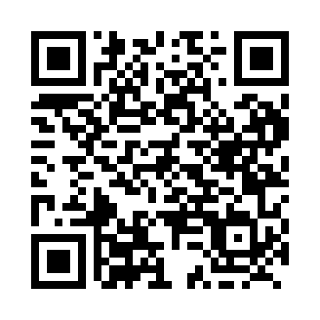
Prayer times for Bernard, Saskatchewan, Canada
Mon 1 Apr 2024 - Tue 30 Apr 2024
High Latitude Method: Angle Based Rule
Prayer Calculation Method: Islamic Society of North America
Asar Calculation Method: Hanafi

Date | Day | Fajr | Sunrise | Dhuhr | Asr | Maghrib | Isha
1 | Mon | 5:08 | 6:43 | 1:12 | 5:40 | 7:42 | 9:17
2 | Tue | 5:05 | 6:40 | 1:12 | 5:41 | 7:44 | 9:19
3 | Wed | 5:03 | 6:38 | 1:11 | 5:42 | 7:45 | 9:21
4 | Thu | 5:00 | 6:36 | 1:11 | 5:43 | 7:47 | 9:23
5 | Fri | 4:58 | 6:34 | 1:11 | 5:44 | 7:49 | 9:25
6 | Sat | 4:55 | 6:32 | 1:10 | 5:46 | 7:50 | 9:27
7 | Sun | 4:52 | 6:30 | 1:10 | 5:47 | 7:52 | 9:29
8 | Mon | 4:50 | 6:27 | 1:10 | 5:48 | 7:53 | 9:31
9 | Tue | 4:47 | 6:25 | 1:10 | 5:49 | 7:55 | 9:34
10 | Wed | 4:44 | 6:23 | 1:09 | 5:50 | 7:57 | 9:36
11 | Thu | 4:42 | 6:21 | 1:09 | 5:51 | 7:58 | 9:38
12 | Fri | 4:39 | 6:19 | 1:09 | 5:52 | 8:00 | 9:40
13 | Sat | 4:36 | 6:17 | 1:09 | 5:53 | 8:02 | 9:42
14 | Sun | 4:34 | 6:14 | 1:08 | 5:55 | 8:03 | 9:44
15 | Mon | 4:31 | 6:12 | 1:08 | 5:56 | 8:05 | 9:47
16 | Tue | 4:28 | 6:10 | 1:08 | 5:57 | 8:06 | 9:49
17 | Wed | 4:26 | 6:08 | 1:08 | 5:58 | 8:08 | 9:51
18 | Thu | 4:23 | 6:06 | 1:07 | 5:59 | 8:10 | 9:53
19 | Fri | 4:20 | 6:04 | 1:07 | 6:00 | 8:11 | 9:56
20 | Sat | 4:17 | 6:02 | 1:07 | 6:01 | 8:13 | 9:58
21 | Sun | 4:15 | 6:00 | 1:07 | 6:02 | 8:15 | 10:00
22 | Mon | 4:12 | 5:58 | 1:07 | 6:03 | 8:16 | 10:03
23 | Tue | 4:09 | 5:56 | 1:06 | 6:04 | 8:18 | 10:05
24 | Wed | 4:06 | 5:54 | 1:06 | 6:05 | 8:19 | 10:07
25 | Thu | 4:04 | 5:52 | 1:06 | 6:06 | 8:21 | 10:10
26 | Fri | 4:01 | 5:50 | 1:06 | 6:07 | 8:23 | 10:12
27 | Sat | 3:58 | 5:48 | 1:06 | 6:08 | 8:24 | 10:15
28 | Sun | 3:55 | 5:46 | 1:06 | 6:09 | 8:26 | 10:17
29 | Mon | 3:53 | 5:45 | 1:06 | 6:10 | 8:27 | 10:20
30 | Tue | 3:50 | 5:43 | 1:05 | 6:11 | 8:29 | 10:22
Prayer times provided by https://www.salahtimes.com

