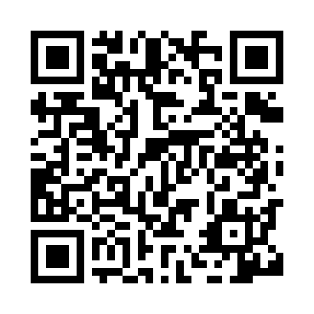
Prayer times for Monbetsu, Japan
Wed 1 May 2024 - Fri 31 May 2024
High Latitude Method: None
Prayer Calculation Method: Muslim World League
Asar Calculation Method: Shafi

Date | Day | Fajr | Sunrise | Dhuhr | Asr | Maghrib | Isha
1 | Wed | 2:22 | 4:17 | 11:24 | 3:19 | 6:31 | 8:18
2 | Thu | 2:20 | 4:16 | 11:24 | 3:20 | 6:32 | 8:20
3 | Fri | 2:18 | 4:15 | 11:23 | 3:20 | 6:33 | 8:22
4 | Sat | 2:16 | 4:13 | 11:23 | 3:20 | 6:34 | 8:24
5 | Sun | 2:14 | 4:12 | 11:23 | 3:21 | 6:35 | 8:26
6 | Mon | 2:12 | 4:10 | 11:23 | 3:21 | 6:37 | 8:28
7 | Tue | 2:10 | 4:09 | 11:23 | 3:21 | 6:38 | 8:29
8 | Wed | 2:08 | 4:08 | 11:23 | 3:22 | 6:39 | 8:31
9 | Thu | 2:06 | 4:07 | 11:23 | 3:22 | 6:40 | 8:33
10 | Fri | 2:04 | 4:05 | 11:23 | 3:23 | 6:41 | 8:35
11 | Sat | 2:02 | 4:04 | 11:23 | 3:23 | 6:42 | 8:37
12 | Sun | 2:00 | 4:03 | 11:23 | 3:23 | 6:44 | 8:39
13 | Mon | 1:58 | 4:02 | 11:23 | 3:24 | 6:45 | 8:40
14 | Tue | 1:56 | 4:01 | 11:23 | 3:24 | 6:46 | 8:42
15 | Wed | 1:54 | 4:00 | 11:23 | 3:25 | 6:47 | 8:44
16 | Thu | 1:52 | 3:58 | 11:23 | 3:25 | 6:48 | 8:46
17 | Fri | 1:50 | 3:57 | 11:23 | 3:25 | 6:49 | 8:48
18 | Sat | 1:48 | 3:56 | 11:23 | 3:26 | 6:50 | 8:50
19 | Sun | 1:46 | 3:55 | 11:23 | 3:26 | 6:51 | 8:51
20 | Mon | 1:45 | 3:54 | 11:23 | 3:26 | 6:52 | 8:53
21 | Tue | 1:43 | 3:53 | 11:23 | 3:27 | 6:53 | 8:55
22 | Wed | 1:41 | 3:53 | 11:23 | 3:27 | 6:54 | 8:57
23 | Thu | 1:39 | 3:52 | 11:23 | 3:27 | 6:55 | 8:58
24 | Fri | 1:38 | 3:51 | 11:23 | 3:28 | 6:56 | 9:00
25 | Sat | 1:36 | 3:50 | 11:24 | 3:28 | 6:57 | 9:02
26 | Sun | 1:35 | 3:49 | 11:24 | 3:29 | 6:58 | 9:03
27 | Mon | 1:33 | 3:49 | 11:24 | 3:29 | 6:59 | 9:05
28 | Tue | 1:31 | 3:48 | 11:24 | 3:29 | 7:00 | 9:07
29 | Wed | 1:30 | 3:47 | 11:24 | 3:30 | 7:01 | 9:08
30 | Thu | 1:29 | 3:47 | 11:24 | 3:30 | 7:02 | 9:10
31 | Fri | 1:27 | 3:46 | 11:24 | 3:30 | 7:03 | 9:11
Prayer times provided by https://www.salahtimes.com

